

Cataloging with MARC, RDA, and Classification Systems

Cataloging with MARC, RDA, and Classification Systems

Reed Hepler and David Horalek
College of Southern Idaho
Twin Falls, Idaho

Cataloging with MARC, RDA, and Classification Systems Copyright © 2023 by College of Southern Idaho is licensed under a Creative Commons Attribution-NonCommercial 4.0 International License, except where otherwise noted.

Contents
- Introduction and Acknowledgements
- H5P Information
- Overview of Cataloging and Copy Cataloging
- Cataloging Overview
- Cataloging Schema
- MARC Records: Information, Examples, and Most Common Entries
- FRBR, WEMI and their Impact on MARC
- RDA Basics and Implications for MARC
- MARC 336, 337, and 338 Fields in RDA
- Call Numbers
- Understanding DDC Call Numbers
- Understanding LC Call (Catalog) Numbers
- Creating Call Numbers using Dewey Decimal Classification
- Creating Cutters using the Library of Congress Classification System
- Classification Website Aids
- Using OCLC Connexion
- Using WebDewey
- Using Classification Web
- Library of Congress Authorities: Subject Headings and Names
- Shelving
- Shelving, Shelflisting, and Work and Author Orders
- Conclusion
- Conclusion
- Appendix A: RDA to MARC 21 maps and workflows
- Appendix B: RDF and the Semantic Web
- Glossary

1

Introduction and Acknowledgements
This book is the product of a desire to combine elements of the most important knowledge found in high-quality textbooks on the subject of Cataloging. Reed Hepler, the Digital Initiatives Librarian and Archivist at the College of Southern Idaho, used his knowledge along with that of the other librarians at CSI and combined it with information found throughout OER, Public Domain, and Open Access resources. The result is this publication on the details of efficient and accurate cataloging.
Special acknowledgement goes to Dave Horalek, the Reference Librarian at the College of Southern Idaho, and Miranda Buren, the Cataloger and Interlibrary Loan Specialist at the same institution, for sharing their expertise and viewpoints. Also, thanks to Teri Fattig, the former director of the CSI Library, for creating effective and thorough quizzes and other assessments.
Trainings created by the Library of Congress have been immensely helpful in creating exercises and adding more expertise than was had by the professionals at CSI. The reader is strongly encouraged to go through the trainings in the Catalogers Learning Workshop of the Library of Congress. As facilitators of the training on the Library of Congress Classification system, Janis L. Young of the Library of Congress and Daniel L. Joudrey of Simmons University merit boundless thanks for their concise, thorough, and accurate description of the system and the Classification Web program.
Special thanks and acknowledgement to OCLC for their support of the WebDewey and Connexion products and services. Connexion is the gold standard for MARC record searching, viewing, interpretation, and retention. WebDewey is the easiest service to use to access and navigate the Dewey Decimal System. It is also helpful in creating unique Dewey numbers when necessary. Not only have they created and maintained these products and services, OCLC also allowed me to include screenshots/screen captures in this book. All rights for these images are reserved by them. These images will allow you to visualize the processes you need to use when creating and interpreting MARC records and Dewey Decimal Numbers. They will also help you somewhat in your work with Library of Congress Call Numbers. Thanks to Michael Campbell and Heather Carlisle specifically for helping me navigate the permissions process for these images.
Connexion®, DDC®, Dewey®, Dewey Decimal Classification®, OCLC®, and WebDewey® are registered trademarks/service
marks of OCLC. All rights are reserved by them.
Every time that you use this textbook, please contact Reed Hepler at rhepler@csi.edu and provide the course title and the number of students involved. If you are using it for professional development, please give the institution and approximately how many people are going to use it at your institution. If you are a lone researcher, worker, or student, feel free to reach out and contact Reed with any revisions, questions, or other comments. This allows him to monitor the impact of the textbook and its associated assessments.

2

H5P Information
This textbook and course includes interactive activities made possible through H5P (HTML 5 Package), which is a learning system created with the HTTP5 language. You will be able to interact with the knowledge you have gained in a variety of ways, including drag-and-drop, fill-in-the-blank, multiple choice, and other varieties. The goal of these activities is to help you internalize your knowledge. Depending on the results of your trials, you will receive certain feedback. You will only be graded upon your final score and you will always be allowed to retry these activities unless your instructor decides to disable that option. There are a few guidelines you should know about typing and interacting with these activities:
- Spelling is important. This is good training for cataloging in general. There are options to allow for imperfect spelling. I have disabled these options. As a cataloger, you will be expected to be precise when entering information in a catalog record and searching for information and data. Spell things accurately
- When you come across an entry that has a long dash, put it in a blank as two short dashes.
- When you see an ampersand, write it out as “and.”
- Don’t give up! Use the feedback that comes with your answers to improve your score.
- If you are confused about an assignment or believe that you got a wrong answer in error, click the “Confused” button on the bottom right corner of the H5P window.

I

Overview of Cataloging and Copy Cataloging

1

Cataloging Overview
Cataloging is perhaps the most exciting subject you could read about. You probably howled with delight when you found you could register for this course, right? Just kidding. I know that even the mention of cataloging and tools used in the process are probably coma-inducing to most people. However, the specifics of cataloging are necessary for librarians, educators, and others to learn. If we know the details of how to catalog, we will know how to help others find the specific items they are looking for. If they are looking for groups of resources, we can help them find several options that fulfill certain criteria.
The goal of this textbook is to explain the details of cataloging in a concise, thorough manner. Interspersed with these explanations will be interactive assessments and experiences in which you can test and demonstrate your knowledge. The average textbook is around 50,000 to 100,000 words. This textbook is around 25,000 words. Even when I update it or add sections, I want to remain in that range. At the most, I will change it to be 30,000 words. There is nothing more pointless than including excessive detail. This is an introductory textbook, and it provides links to more detailed sources of information if you would like to browse those.
Describing, categorizing, and classifying information resources is a detailed process that can involve up to three or four schemata at once. Essential to the best practices of cataloging is the use of controlled entries when creating records. This concept is called controlled vocabulary, and it influences virtually every decision of the cataloger.

Use of Controlled Vocabularies
One way to encourage good names for a given resource domain is to establish a controlled vocabulary. This is like a fixed or closed dictionary that includes the terms that can be used in a particular domain. A controlled vocabulary shrinks the number of words used and leaves behind a set of words with precisely defined meanings and rules governing their use. The results of using a set of specified terms include the elimination of undesirable associations and the removal of synonyms and homonyms. In other words, the possibly entries in a field are streamlined to be as precise and thorough as possible while also avoiding any confusion.
A controlled vocabulary is not simply a set of allowed words; it also includes their definitions and often specifies rules by which the vocabulary terms can be used and combined. Different domains can create specific controlled vocabularies for their own purposes, but the important thing is that the vocabulary be used consistently throughout that domain.
For bibliographic resources important aspects of vocabulary control include determining the authoritative forms for author names, uniform titles of works, and the set of terms by which a particular subject will be known. In library science, the process of creating and maintaining these standard names and terms is known as authority control.
When evaluating what name to use for an author, librarians typically look for the name form that is used most commonly across that author’s body of work while conforming to rules for handling prefixes, suffixes and other name parts that often cause name variations. For example, a name like that of Johann Wolfgang von Goëthe might be alphabetized as both a “G” name and a “V” name, but using “G” is the authoritative way. “See” and “see also” references then map the variations to the authoritative name. The Library of Congress has specific names and formats used for the majority of authors. These are called Name Authorities and will be discussed later.

Controlled Vocabularies and Content Rules
Content rules are similar to controlled vocabularies because they also limit the possible values that can be used in descriptions. Instead of specifying a fixed set of values, content rules typically restrict descriptions by requiring them to be of a particular data type (integer, Boolean, Date, and so on). Possible values are constrained by logical expressions (e.g., a value must be between 0 and 99) or regular expressions (e.g., must be a string of length 5 that must begin with a number). Content rules like these are used to ensure valid descriptions when people enter them in web forms or other applications.

Vocabulary Control as Dimensionality Reduction
In most cases a controlled vocabulary is a subset of the natural or “uncontrolled” vocabulary, but sometimes it is a new set of invented terms. The goal of a controlled vocabulary is to reduce the number of descriptive terms assignable to a resource. Thus, controlled vocabulary and content rules bring about a phenomenon called “dimensionality reduction.” In other words, they are used to help catalogers in reducing the number of components in a description. These facets of catalog records are driven by a plethora of pretentious-sounding processes, theories, and paradigms.
These terms, and the processes of using them, might sound imposing. Indeed, they are computationally complex, but they all have the same simple concept at their core: the features or properties that describe a resource are often highly correlated. For example, a document that contains the word “religion” is more likely to contain the words “faith” and “ritual” than a document that does not. Similar correlations exist among the visual features used to describe images and the acoustic features that describe music. Dimensionality reduction techniques analyze the correlations between resource descriptions to transform a large set of descriptions into a much smaller set of uncorrelated ones.
Here is an oversimplified example that illustrates the idea. Suppose we have a collection of resources, and every resource described as “big” is also described as “red,” and every “small” resource is also “green.” This perfect correlation between color and size means that either of these properties is sufficient to distinguish “big red” things from “small green” ones, and we do not need clever algorithms to figure that out. But if we have thousands of properties and the correlations are only partial, we need the sophisticated statistical approaches to choose the optimal set of description properties and terms, and in some techniques the dimensions that remain are called “latent” or “synthetic” ones because they are statistically optimal but do not map directly to resource properties.

Creating Resource Descriptions
Resource descriptions can be created by professionals, by the authors or creators of resources, by users, or by computational or automated means.
From the traditional perspective of library and information science with its emphasis on bibliographic description, these modes of creation imply different levels of description complexity and sophistication; Taylor and Joudrey, in their classic book The Organization of Information, suggest that professionals create rich descriptions, untrained users at best create structured ones, and automated processes create simple ones.
This classification reflects a disciplinary and historical bias more than reality. “Simple” resource descriptions are “no more than data extracted from the resource itself… the search engine approach to organizing the web through automated indexing techniques.”
A better notion of levels of resource description is one based on the amount of interpretation imposed by the description, an approach that focuses on the descriptions themselves rather than on their methods of creation.
Professionally-created resource descriptions, author- or user-created descriptions, and computational or automated descriptions each have strengths and limitations that impose tradeoffs. A natural solution is to try to combine desirable aspects from each in hybrid approaches. For example, the vocabulary for a new resource domain may arise from tagging by end users but then be refined by professionals, lay classifiers may create descriptions with help from software tools that suggest possible terms, or software that creates descriptions can be improved by training it with human-generated descriptions.

Resource Description by Professionals
Before the web made it possible for almost anyone to create, publish, and describe their own resources and to describe those created and published by others, resource description was generally done by professionals in institutional contexts. Professional indexers and catalogers described bibliographic and museum resources after having been trained to learn the concepts, controlled descriptive vocabularies, and the relevant standards. In information systems domains professional data and process analysts, technical writers, and others created similarly rigorous descriptions after receiving analogous training. We have called these types of resource descriptions institutional ones to highlight the contrast between those created according to standards and those created informally in ad hoc ways, especially by untrained or undisciplined individuals.

Resource Description by Authors or Creators
The author or creator of a resource can be presumed to understand the reasons why and the purposes for which the resource can be used. And, presumably, most authors want to be read, so they will describe their resources in ways that will appeal to and be useful to their intended users. However, these descriptions are unlikely to use the controlled vocabularies and standards that professional catalogers would use.

Resource Description by Users
Today’s web contains a staggering number of resources, most of which are primary information resources published as web content, but many others are resources that stand for “in the world” physical resources. Most of these resources are being described by their users rather than by professionals or by their authors. These “at large” users are most often creating descriptions for their own benefit when they assign tags or ratings to web resources, and they are unlikely to use standard or controlled descriptors when they do so. The resulting variability can be a problem if creating the description requires judgment on the tagger’s part. Most people can agree on the length of a particular music file but they may differ wildly when it comes to determining to which musical genre that file belongs. Fortunately most web users implicitly recognize that the potential value in these “Web 2.0” or “user-generated content” applications will be greater if they avoid egocentric descriptions. In addition, the statistics of large sample sizes inevitably leads to some agreement in descriptions on the most popular applications because idiosyncratic descriptions are dominated in the frequency distribution by the more conventional ones.
We are not suggesting that professional descriptions are always of high quality and utility, and socially produced ones are always of low quality and utility. Rather, it is important to understand the limitations and qualifications of descriptions produced in each way. Tagging lowers the barrier to entry for description, making organizing more accessible and creating descriptions that reflects a variety of viewpoints. However, when many tags are associated with a resource, it increases recall while decreasing precision. This causes immense problems when catalogers and other professionals seek to categorize and classify resources. Ofttimes, socially-produced tags are simply ignored and replaced with standardized, controlled metadata terms.

Evaluating Resource Descriptions

When professionals create resource descriptions in a centralized manner, which has long been the standard practice for many resources in libraries, there is a natural focus on quality at the point of creation to ensure that the appropriate controlled vocabularies and standards have been used. However, the need for resource description generalizes to resource domains outside of the traditional bibliographic one, and other quality considerations emerge in those contexts.
Resource descriptions in private sector firms are essential to running the business and in interacting efficiently with suppliers, partners, and customers. Compared to the public sector, there is much greater emphasis on the economics and strategy of resource description. What is the value of resource description? Who will bear the costs of producing them? Which of the competing industry standards will be followed? Some of these decisions are not free choices as much as they are constraints imposed as a condition of doing business with a dominant economic partner, which is sometimes a governmental entity.
For example, a firm like Wal-Mart with enormous market power can dictate terms and standards to its suppliers because the long-term benefits of a Wal-Mart contract usually make the initial accommodation worthwhile. Likewise, governments often require their suppliers to conform to open standards to avoid lock-in to proprietary technologies.
In both the public and private sectors there is increased use of computational techniques for creating resource descriptions because the number of resources to be described is simply too great to allow for professional description.
A great deal of work in text data mining, web page classification, semantic enrichment, and other similar research areas is already under way and is significantly lowering the cost of producing useful resource descriptions. Some museums have embraced approaches that automatically create user-oriented resource descriptions and new user interfaces for searching and browsing by transforming the professional descriptions in their internal collections management systems. Google’s ambitious project to digitize millions of books has been criticized for the quality of its algorithmically extracted resource descriptions, but we can expect that computer scientists will put the Google book corpus to good use as a research test bed to improve the techniques.
Web 2.0 applications that derive their value from the aggregation and interpretation of user-generated content can be viewed as voluntarily ceding their authority to describe and organize resources to their users, who then tag or rate them as they see fit. In this context the consistency of resource description, or the lack of it, becomes an important issue, and many sites are using technology or incentives to guide users to create better descriptions.

Copy Cataloging
Evaluating and improving upon existing descriptions and catalog records may seem to be a waste of time. However, it is a large part of modern cataloging operations. Copy cataloging is the practice of creating a new cataloging record based on a preexisting catalog record. This could be a record created by someone at your own institution or a record obtained form someone else. This is contrasted with original cataloging, which occurs when a cataloger creates a completely new record for an item. Copy cataloging has become increasingly mainstream as libraries develop networks and consortiums. The proliferation of services by OCLC has also affected this trend. OCLC provides access to preexisting catalog records, from catalogers can choose one that best meets their needs. Copy cataloging is a major boon to library workers as they will not have to fill all of the MARC records out manually. Ofttimes, only a few tweaks are needed to make the preexisting record compatible with the item in one’s own library holdings. For example, the format, edition number, and call number may have to be changed in a MARC record, but that may be the only changes necessary.

Test Your Knowledge
An interactive H5P element has been excluded from this version of the text. You can view it online here:
https://csi.pressbooks.pub/cataloging/?p=5#h5p-2

Types of Catalogs and Databases
Before we explore the intricacies of cataloging schemata and tools, we must first understand why we need specialized controlled vocabulary and authority records. After all, couldn’t we just put all this information on a website so that a search on a search engine or database will turn it up? Well, yes and no. Search engines occasionally pick up library catalog listings, especially if those have been created based on standardized practices. However, for use in the library system, a record must be placed into a specific type of database.
Another major difference between search engines and databases and catalogs is that the latter two have a wide range of delimiters, whereas a search engine may only have delimiters regarding the format of a result, time of publication, or author metadata. Boolean operators, (AND, OR, NOT, etc.) are even more important when using search engines, although they are also occasionally useful in databases and catalogs.
The major types of catalogs, databases and related services include:
*Integrated Library System: An ILS, also called a Library Management System (LMS), is a service that combines an Open Public Access Catalog (OPAC) with circulation and patron information as well as financial information when necessary. There are multiple facets of this system, and each of these services may be provided by individual providers or multiple vendors. ILS systems can also provide connections to other services, such as databases and links to consortia. While Card Catalogs only had three search options, the ILS adds a fourth option: specific metadata such as whole or partial call numbers can be used to search for books.
*Union Catalog: This type of catalog is exemplified by OCLC’s WorldCat. A union catalog is simply an OPAC that is used by multiple libraries who are functioning as a consortium and have fluid collections that can be loaned to each other. This type of catalog facilitates loaning items from one library to another, such as OCLC’s Inter-Library Loan service.
*Discovery System: This system is a combination of a catalog and a search engine. CSI Library uses a Discovery System that interfaces with our catalog for multiple resources. For our library holdings we have a Discovery System hosted by EbscoHost. For our Open Access materials, we have a system provided by SirsiDynix.
*Standard Database: A regular database holds items with copious amounts of data, including creation, title, author, subject, and other metadata. This database may or may not be open. It does not include information about anything other than the data it holds, although site traffic data may be recorded by third parties. Often, the collections in these databases have not been curated. This means they have not been specifically selected, standardized and/or evaluated.
*Card Catalog: This was the initial iteration of a database. It was completely physical with no digital facets. There were only three types of searches one could perform using a card catalog. A user could search for works by Title, by Author, and by Subject. For a time, this was all information that was necessary for a thorough and accurate library search. However, in the increasingly modernizing world, a new iteration of catalog was necessary. This type of catalog was often accompanied by a shelf list, which listed all books in a library by order of their call number.
An interactive H5P element has been excluded from this version of the text. You can view it online here:
https://csi.pressbooks.pub/cataloging/?p=5#h5p-3
This work was adapted from the sections “Naming Resources” and “The Process of Describing Resources” from The Discipline of Organizing by Robert J. Glushko. This work has a Creative Commons Attribution-NonCommercial 4.0 International License.

Joudrey, D. N., Taylor, A. G., & Wisser, K. M. (2018).
(4th ed.), Libraries Unlimited, 184-186.

Joudrey, D. N., Taylor, A. G., & Wisser, K. M. (2018).
(4th ed.), Libraries Unlimited, 184.

II

Cataloging Schema

2

MARC Records: Information, Examples, and Most Common Entries

MARC Overview
One of the main schemata for describing information items is called MAchine-Readable (Bibliographic) Catalog Records (MARC). This system was created in the 1960s and has been continuously revised since that time to fit the metadata needs of a continuously modernizing world. The current iteration of MARC, MARC 21, was created in 1999. This version has been subject to continuous smaller changes so as to remain more or less evergreen. Trimming and pruning are performed instead of planting an entirely new tree.
Integral to one’s understanding of the complexity of MARC records is a knowledge of the discrete types of data contained in the symbols present. One symbol can refer to multiple types of metadata depending on its presence in the MARC record.

Sections of a MARC Record There are three main sections of a MARC Record: Leader: This is the shortest section in a MARC record. It consists of 24 sequential symbols or characters. Individual symbols or groups of symbols show different types of data in the record. This is the first part of the record. Directory: This record states the location of each variable field in the MARC record. It also states the length of the record. The directory entry for every variable is only 12 character positions. All directories end with the presence of RS, which signifies the end of the record. Variable fields: This is what most people think when they consider MARC records. In fact, it is the most important element of the MARC record. There are three main types of Variable fields, which will be examined later. MARC Elements There are three types of metadata variable fields in the Variable field Section of a MARC record: Tags (also occasionally called the Field Code): Every tag consists of three digits. This is the most broad variable field, and there is only one tag per section of a MARC record. They can only be followed by indicators and subfield codes. Every three-digit number stands for a certain aspect of an item’s metadata. For example, a field marked 600 would contain items related to a personal name related to the item, whereas the 610 field is reserved for corporate or entity names. Furthermore, 650 signifies that the following information is related to a topic discussed in the item and 651 indicates a geographic place. As an item can have more than one subject or author, these tags are repeatable in an item. Indicators: These are optional clarifiers that follow tags. They have only one digit. There are two spaces for indicators. This may cause some to assume that an indicator is two digits, but each digit stands for a different clarification. Some fields use only the first or second indicator while others use both indicator fields. If an indicator field is not used, it is filled by the number sign (#). Subfield Codes: Immediately following the indicators are subfield codes. These are also called “delimiters” occasionally. There are two symbols in a subfield code. The first is the subfield symbol, which is represented in this textbook by a dollar sign ($). The second is a lowercase letter of the alphabet or a number. After the subfield, or delimiter, code, the data entry of the subfield is given. In theory, the first subfield would be signified by “$a.” However, sometimes this subfield indicator is omitted as a given. The other subfield indicators are always used. Examples of MARC fields Let us look at some examples of MARC fields, their tags, and their indicators and delimiters. The following fields would be some of those present in an entry for an omnibus edition of the first three (published) books in the Foundation trilogy of Isaac Asimov. 020##$a9780380001019$c119.14USD 040##$aOCLC 08200$a813/.5/4 1001#$aAsimov, Isaac$d1920-1992 1304#$aThe Foundation trilogy: three classics of Science Fiction.$pFoundation.$pFoundation and Empire.$pSecond Foundation.$lEnglish.$f1974. 24514$aThe Foundation trilogy :$bthree classics of Science Fiction./$c Asimov, Isaac 1920-1992 650#0$aScience fiction. 650#$aFuture, The, in literature. 650#$aPsychohistory–fiction. This example is given without spaces to show you how MARC records might appear on your computer screen. Some systems, such as Connexion, have options to have spaces between field codes, indicators, and subfield indicators. Future examples and your assignments will have spaces, but I wanted to show you the default and traditional appearance of a MARC record. Pay attention to the 245 field for this next exercise, and perhaps look at the MARC 21 Bibliographic Page for this field. An interactive H5P element has been excluded from this version of the text. You can view it online here: https://csi.pressbooks.pub/cataloging/?p=41#h5p-15 Digits in Variable Fields Now that we know the format, order, and importance of each of the types of MARC fields, what are the most ubiquitous and necessary entries in these fields? The Library of Congress has made an excellent page that describes the attributes above and lists the most common MARC fields used in bibliographic records, along with all indicators and the most common delimiters. First digits in Variable Fields There are ten general categories of MARC fields: 0XX: Identification symbols (Library of Congress control numbers, International Standard Book Number) 1XX: Main entries (author name, title of the book) 2XX: Titles and related information 3XX: Physical description 4XX: Indicators of whether or not an item is in a series 5XX: Notes 6XX: Subject access fields (including names of individuals) 7XX: Entries other than subjects or series information 8XX: Entries to series and other related works 9XX: A category created to allow local institutions to record their own relevant metadata Second and Third digits in Variable Fields These digits act as subdivisions for the first-digit categories. Each of the categories below, when applied to the 1XX, 5XX, 6XX, and 7XX categories, describe when certain people, institutions, or works are subjects of the current work in question. X00: Personal names X10: Corporate names X11: Meeting names X30: Uniform titles X40: Bibliographic titles X50: Topical terms X51: Geographic names Occasionally, changes have to be made in the MARC record. These changes are often performed by local institutions. They are followed by the symbol | . The author field for the Foundation trilogy is 100 1# $a Asimov, Isaac $d 1920-1992. The “100” field is designated as the indicator for the name of the author. The first indicator of this field states that the surname is the first name in the entry. In the above example for the Foundation trilogy, there were three subject fields. 650 #0 $a Science fiction. 650 #0 $a Future, The, in literature. 650 $0 $a Psychohistory–fiction. The first digit is 6, so we know that the field will be related to a subject in the work. the second and third digits are 5 and 0. This means that the subject of the work is topical, not a person, group, corporation, or geographical area. “Science fiction.” is the authorized heading of the Library of Congress for all works of science fiction. “Future, The, in literature.” is the authorized heading of the Library of Congress for all works that discuss the future. “Psychohistory” is the name of both a historical theory in reality and a fictional algorithm created by Hari Seldon, a major character in the Foundation series. In order to ensure that readers of this record know that the psychohistory referred to is the fictional construct, hyphens and the word “fiction” are added. We will discuss Library of Congress Authority Records later in this book. Most Ubiquitous/Important MARC Fields Here are the most common MARC fields, some of which will be discussed in greater detail in later sections: 010: Library of Congress Control Number: This is possibly the most simple field in a MARC record. Both indicators are not used. The only indicator is $a and is followed by the LOC control number. Each work has a unique LOC control number to identify it. 020: International Standard Book Number: This is another identification number. Usually, there are only ten or thirteen digits in an ISBN. 040: Cataloging Source: This is the LOC or the OCLC or another institution. It is the source from which the entire MARC record was obtained. Like the first two fields, indicators are undefined. 082: Dewey Decimal classification number of the item. The indicators show whether the DDC number of an item is from the full or abridged edition and which organization assigned the Dewey Decimal Classification number. Subfields other than $a give context to the number, including repeating the assignation information. 100: Personal name of the author of the work: The first indicator of the field states the first name (personal, surname, or family) that is used in the entry. The second indicator is undefined. Subfields include designations for surnames, personal names, numbers, titles, and birth and death dates. The types and order of data in this field are governed by the LOC Authority Record for the author, if one exists. If the author does not have an Authority Record, institutional policy should be followed. Often, this means using the surname and first name of the author, followed by birth and death dates. 130/240: These fields contain the uniform title (or the main title) of the item being described in the MARC Record. The 130 field is the most common iteration of the Title Field. 240, however, is useful when a work can have multiple titles given to it, either colloquially or through multiple publications of the same work over time. While delimiters $a, $l, and $f have the same meaning in both fields, those three delimiters subfield indicators are the only ones present in Field 240. Only with Field 130 can a cataloger record the names of individual sections and the version of the work that has been used to create a certain item. 245: This field repeats the title of the item and other information about the work. This field is known as the “Title Proper” field of the MARC record. If the title in this field is the same as the preferred title of the field, 130 or 240 fields are not needed. At the very least, the title proper does not needed to be included in these fields if it is recorded in Field 245. 250: If a work is a new edition of a previous work, this field contains information about the current edition. 260, 264: Publishing and distribution information, including data about the organization, place, and date of the item, are included in this record. The first and only indicator describes the certainty of the cataloger in reference to the publication information provided. Subfields describe name and location of the publisher, as well as the date of publication, the date of manufacture, and the materials used to create the item. 300: This field is designated as the record of the physical, tangible aspects of the item. Things like the number of pages, descriptions of the illustrations on the book, or ancillary material are located in the 300 field. Each of these have their own subfields. For example, the number of pages is under $a while the description of the illustration on the back cover of a book would be contained in subfield $b. 336, 337, 338: These are the Content, Media, and Carrier Type fields. These fields, like other fields that have entries from other institutions, are subject to a controlled vocabulary. This means that the entries in these fields can only contain certain entries. The vocabulary assigned to these fields is determined by corresponding data in the Resource Description and Access (RDA) schema. These fields will be discussed in a later page. 490: This field places the item and its work in a series with other items. It simply states the name of the series in which the work is placed. It may also add the place of the work in that series through assigning a volume number. 500: This field is only used if a cataloger needs to include information about the source of any information in the record, related items, or a description of the main subjects in the item. 520: This field is a summary of the information in the item. This should be an extremely short entry. The summary can be designated as a standard book summary, a review, a scope and content note (for archival cataloging), or an abstract. 521: Target audience of the item. Indicators can specify whether the range used in this field is reading grade, age range, grade, and motivation. Subfields impart more information about the target audience and the source that assigned a target audience to the manifestation that has been incorporated into the item. 600: This field contains information about the human subjects of a work. The entries in this field are most often copied from the Library of Congress Authorities. The first indicator of the field is the same as the first in the 130 field. The second indicator gives the source for the subject statement. Subfields include information regarding the personal name, titles, birth and death dates, and other information. 610: This field designates corporate and institution organizations as the subjects of a particular work. The first indicator in this field indicates whether or not the name is inverted or if the name belongs to a government jurisdiction rather than a private group. The second indicator is the same as the second indicator for Field 600. Subfields include places for the name, the time period associated with the organization, and the geographic area affected by the group. 650: This subject, as stated above, is reserved for topics that are not groups or individuals. Thematic subjects can include many topics, from arts to science to literature, to activist movements. The first indicator is the level of the subject. The second indicator is the source of the subject heading. For example, if the second indicator is a 0, the term was retrieved from the Library of Congress Subject Headings. If that indicator is a 1, the term was taken from the LC Subject Headings for children’s literature. Of particular importance in this field are the subfields $0, $v, $x, and $y. 651: This field holds only geographic names and places. The first indicator of this field is undefined. The second indicator is the same as the second indicator for all other 6XX fields mentioned on this page. Subfields describe the formal name of an area, the chronological period of the area covered in the item, and the control number associated with the authority record of the term. 655: This field examines the genre of the item. Subfields examine the history, provenance, and materials common to this genre and the justification for placing the item in this genre. As with many fields, a 7 in the second indicator space means that the term is found in an external place that is not a common source for data. Using this indicator means that the cataloger will have to justify using a particular source for their genre term. It may also require a $7 subfield, which examines the provenance process through which a cataloger determined particular data entries. 700 and 710: Fields for additional personal and corporate names. The 700s in general are additional names. Entries in this field include personal names of coauthors, compilers, and contributors. Translators and arrangers are also listed in this field range. 852: Physical location of the item in the Library’s holdings. The first indicator exposes the system used to classify all objects in the library’s holdings. The second indicates whether or not the classification strategy is the primary scheme. 856: Electronic location of the item and instructions for how to access it. The first indicator is the method through which a user can access the item. The next indicator says whether the item that will be accessed is the resource itself, a conversion of the resource, or a combination of both. Subfields contain URLs, database host names, provenance of the item, and copyright and other terms regulating access and use of the item. 883: This field contains the provenance of the metadata contained in this record. Metadata is much more than the pithy and trite “data about data” definition bandied about for decades. It is essential information that puts the data (in this case, the library item) in the proper context. Only through analyzing the item in the context of the metadata can the user fully appreciate the work that has been manifested. For information about using Connexion to look at MARC record data, go to the Using OCLC Connexion page. A login to Connexion will be necessary to complete the activity below, but this will talk you through getting to the required MARC record. Later on, we will discover more about using Connexion to a fuller extent. An interactive H5P element has been excluded from this version of the text. You can view it online here: https://csi.pressbooks.pub/cataloging/?p=41#h5p-17 Additional Information There are multiple standards used to identify the proper way to create entries in the fields and subfields of MARC records. All of these standards are maintained by the Library of Congress and include the MARC Format for Authority Data, MARC 21 Format for Classification Data, and the MARC 21 Format for Bibliographic Data. It is highly recommended that you bookmark these sources for information, especially the Bibliographic page. This will come in handy later in this book as well as throughout your librarianship. It is free, easy to use, and thorough. The other pages in the MARC LOC website, the Holdings, Classification, and Community pages, are also useful but will not be accessed as much during cataloging.

Library of Congress. (2008, April 22).
. Retrieved December 5, 2022, from
.

Library of Congress. (2009, October 17).
. Understanding MARC Bibliographic: Parts 7 to 10. Retrieved December 5, 2022, from
.

Library of Congress. (2008, April 22).
. Retrieved December 5, 2022, from
.

Library of Congress. (2022, July 7).
. Retrieved December 5, 2022, from
.

3

FRBR, WEMI and their Impact on MARC
MARC records are not the only configuration for describing, categorizing, and classifying items. MARC 21 records have been influenced by Functional Requirements for Bibliographic Records (FRBR). This system is a theoretical one that categorizes and describes items according to their relationship to the information contained inside them.
It is important to understand the difference between various tools used or referred to in the cataloging community. FRBR is an ideology, a conceptual model. It is not tangible. There is no FRBR software. It simply guides how catalogers think about items, subjects, and people so that cataloging makes intuitive sense. RDA is a content standard. This regulates how certain metadata are expressed to ensure standardization. MARC, on the other hand, is the format in which most cataloging records are generated. MARC usesRDA to express metadata in a way that aligns with FRBR. The relationships between these three items, and the fact that they are not the same type of tool, are important to know before you begin to work with them.
MARC and RDA possess information about the physical characteristics, author, title, and number of pages of a particular item. FRBR describes the items by exploring their relationships the original iteration of its information as provided by the author. This information is then combined with the other metadata provided by MARC and RDA to give a thorough, complex description of each item in the library’s holdings. Additionally, the relationship between one item and the others in the library’s holdings is also made manifest. In order to complete this, catalogers use a system called WEMI.

WEMI Hierarchy
There are four main steps in the entity hierarchy of WEMI:
- Work: A work is the broadest level of the hierarchy. It is the original iteration of an idea created by an author. For example, Second Foundation in The Foundation trilogy was published by Isaac Asimov in 1952. While there was a first edition of the book, that first edition is not the work. Instead, the words and ideas within that edition constitute the work. A work is represented by a title and an author. Works can be related to each other if one is derived from the other. Some of the fields of the MARC record that deal with the Work hierarchy are 100, 130, 240, 245, and 380.
- Expression: The level below a work is an expression. This is a particular format in which the work has been presented. For example, a play based on Second Foundation would be a different expression than the text version in the book. Alternate translations of the work may also be considered discrete expressions. A sign of this is the fact that many library systems have different call numbers for different translations of the same work. For example, the CSI Library has a different LOC call number for works in Spanish than for those in English. For example, Harry Potter and the Sorcerer’s Stone, the American manifestation of Harry Potter and the Philosopher’s Stone, has a LOC call number at the CSI Library of FIC .R69 H371 1998. The Spanish translation, Harry Potter y la piedra filosofal, has a call number of SPA FIC .R69 H371 2001. Some of the Expression-level MARC fields include 130, 240, 255, 336, 507, 520, and 546.
- Manifestation: Yet another level in this system is the manifestation. This is often confused for an item, but these two things are not the same. An edition may be considered a manifestation of a particular expression. Multiple items of the same edition can all be considered individual parts of a particular manifestation. For example, if a library buys two copies of the same edition of a book due to high circulation, these may be considered to be iterations of the same manifestation. If, on the other hand, they are different editions, then they are different manifestations. There are many manifestation-level MARC fields, including 245, 250, 264, 300, 319, 337, 338, 347, 490, 500, and 856.
- Item: The item is the individual copy of a book. Each item has its own MARC and FRBR record. An item is represented by a call number, whether that number is part of the Library of Congress Classification System or the Dewey Decimal System. Item-specific parts of the MARC record include the item identifier, which can be included in multiple fields, and fields in the 5XX range which are related to restrictions.
An interactive H5P element has been excluded from this version of the text. You can view it online here:
https://csi.pressbooks.pub/cataloging/?p=43#h5p-26

Trinity of FRBR
There are three elements in the FRBR system. The parts of the WEMI hierarchy are called entities. Specifically, these are called Group 1 entities. Group 2 entities are people and organizations or corporate bodies. Group 3 entities are the subjects that can be discussed by works. Group 1 and Group 2 entities can be Group 3 entities if there are works written about them. Group 2 entities are described by multiple MARC fields in different contexts. Individuals can be described by MARC fields 100, multiple fields in the 37X range, 670, and 700. Families are described by 100, 376, and 670. Corporate organizations are described by 110, 111, 368, 370, and 670.
The second aspect of FRBR is the relationship between multiple entities. For example, in the sentence “William Shakespeare wrote a play about Macbeth,” the phrase “wrote a play” is the relationship.
The third relationship in the FRBR triangle is the attributes of the item. This is where the rest of the MARC or RDA record comes in. The metadata regarding editions, text font, page numbers, subjects, and authors are all considered attributes of an item. Relationships between an item and its author can also form connections between other works created by that author. Attributes function as a way to build less direct connections and imply relationships. On the front page recto (front side) of the item are usually the title, author, and publisher. On the verso, or back side, are also the title, author, and publisher information. Additionally, subject, publication information, language, and many other attributes are listed.
An interactive H5P element has been excluded from this version of the text. You can view it online here:
https://csi.pressbooks.pub/cataloging/?p=43#h5p-5

Content relationships
The major relationship regarding works in the above trifecta is those regarding works and their subjects. Content relationships explain how works are related to each other. Some are different manifestations or expressions of the same work. The information in two items that are the same work are essentially the same, barring any information lost by versioning, translation, or the creation of a new edition. These items may be said to be equivalent.
Some are derivations of other works. Therefore, the information in the derivation is only part of the information in the original work. New information may be added to this derivation. Examples of derivations include dramatizations, subtle changes to the themes, perspective changes, and other modifications.
Another relationship occurs when one work is descriptive of another work. These include commentaries, annotated and edited anthologies, and reviews. The information in the original work is analyzed and may or may not be fully dealt with in the descriptive work.

User Tasks
One may ask, “other than facilitating cataloger understanding of the need for schemata like MARC and RDA, what does FRBR do?” This system actually does more for users than may be immediately apparent. It facilitates five actions that all users perform when they engage with items. These user actions replace the three “Objects of Catalogs” that Charles Ammi Cutter, one of the major pioneers of cataloging, theorized. According to him, there were three major finding goals of users that a catalog should facilitate: finding a a specific book, finding groups of books by author, subject, or genre, and finding a book that specifically suits their needs. FRBR expanded upon these functions to create their new “user tasks.”
- Find: A user encounters multiple possible answers to a query. They do this through examining the attributes and relationships of works. To facilitate this task the information system needs to support searching by offering appropriate search elements or functionality.
- Identify: If a user is looking for specific attributes and/or relationships, they can locate the exact copy or manifestation they are looking for. If they are looking for a wider range of possible answers to their query, they can also identify any item of several that fulfills their needs. To facilitate this task the information system seeks to clearly describe the resources it covers. The description should be recognizable to the user and easily interpreted.
- Select: A user can view or examine only those items that fulfill their criteria. To facilitate this task the information system needs to allow/support relevance judgments by providing sufficient appropriate information about the resources found to allow the user to make this determination.
- Obtain: As long as restrictions allow, a user can obtain the item, or access to it or a version of it, through the machinations facilitated by the catalog. To fulfill this task the information system needs to either provide direct links to online information or location information for physical resources. It also needs to give any instructions required to complete the transaction or any restrictions on access.
- Explore: The explore task is the most open-ended of the user tasks. The user may be browsing, relating one resource to another, making unexpected connections, or getting familiar with the information resources available for future use. The explore task acknowledges the importance of serendipity in information seeking. To facilitate this task the information system seeks to support discovery by making relationships explicit and by providing contextual information and navigation functionality.
An interactive H5P element has been excluded from this version of the text. You can view it online here:
https://csi.pressbooks.pub/cataloging/?p=43#h5p-1
If these ideas seem difficult to understand, you are not the only one confused by this. View this diagram of the relationship between the English translation of War and Peace and its translator, the author, and the original work, which was written in Russian.

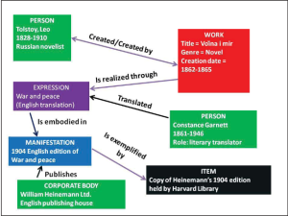

In order to fully explore and delineate the relationships and attributes of entities to fulfill user tasks, some have stated that a new way of recording metadata must be made. For this reason, the Resource Description Framework (RDF) was invented. This was also partially a response to the need for controlled vocabulary. For more information about this framework and changes in schemata, visit Appendix B.
For a much more thorough and complex, yet understandable, explanation of this system read the FRBR Library Resource Model document created by the International Federation of Library Associations and Institutions. Another simple resource was created by Dr. Pamela Thomas of the Illinois Heartland Library System.
This chapter is a remix of several works, including:
FRBR and RDA: What they are and how they may affect the future of libraries by C.R. Croissant. This work is licensed with a Creative Commons Non-Commercial 4.0 International License.
FRBR-Library Reference Model, by Pat Riva, Patrick Le Boeuf, and Maja Zumer, licensed with a Creative Commons Attribution License.

4

RDA Basics and Implications for MARC
Another schema is called Resource Description and Access, or RDA. It was created in the 2010s to replace an outdated schema called AACR2. Initially, this schema was utilized museums. However, it become more prominent in libraries as it was developed to become ubiquitous. It was apparent as early as 2007 that there would be no way for RDA and MARC21 to coexist and not have some connection between the two schemata. In fact, the overseers of MARC deliberately altered MARC21 to become more compatible with RDA.
The focus of RDA is to provide users, and catalogers, with an object-oriented way of describing a resource. In other words, RDA wants to establish a clear relationship between one item and other items within a collection. It also wants to describe relationships between items and authors and between multiple editions of the same work. In this way, RDA is similar to FRBR.
For example, RDA does not initially categorize an information resource based on its physical type. Instead, it categorizes all physical items based on the rate or status of information publication and updating. The three main types of format are serials, which are published at regular or irregular intervals as discrete items that are all related (newspapers, magazines, etc.), monographs, which are single-volume or multiple-volume items that are considered a complete work, or integrated resources, which are items that are continuously updated with new editions. The new information is integrated into the original resource and republished.
An interactive H5P element has been excluded from this version of the text. You can view it online here:
https://csi.pressbooks.pub/cataloging/?p=45#h5p-4
Intrinsic in the object-based orientation of RDA is the separation between the many elements of an item. For example, separate pieces of metadata describe the format of the information in an item and the format of the item itself. According to a report by the Library of Congress, this aspect of RDA is especially useful if preservationists or users want to convert data on an item into another format. To designate that a MARC record has been created through the RDA system, Field 040 subfield $e has “rda” as an entry. There are various rules regarding cataloging processes in RDA. For example, abbreviations should never be used. Nor should filler terms such as “etc.,” or “et al.,” unless these are used in a title. Author names should be written according to their natural order in Field 245, but according to the appropriate Authorities in Fields 100, 600, and so on.
RDA can be extremely complicated to understand. At times, it is necessary to view RDA in its historical context and in comparison to other schemata. FRBR was the forerunner to the RDA, and RDA and MARC are used together. The Library of Congress has created a training complete with PowerPoint slides, a training manual, and exercises, on these three schemata. FRBR, RDA, and MARC helps catalogers see the connections between these three systems. Many other trainings, including a six-module training on RDA specifically, exist on the RDA Training Materials page of the LOC website.
For maps and other resources that explain the connections between RDA and MARC21, see Appendix A.

Apply Your Knowledge
Let’s combine your knowledge of MARC with knowledge of RDA. You have learned about the MARC fields, indicators, subfield symbols, and the data that are affiliated with these aspects of item records. Now see how you would write and interpret MARC records with MARC field and subfield symbols according to the RDA schema. You will only have to work with fields 100, 130, 240, and 245. Like on previous pages, it would be helpful to have the MARC 21 Bibliographic and Authority Data Library of Congress pages handy.
An interactive H5P element has been excluded from this version of the text. You can view it online here:
https://csi.pressbooks.pub/cataloging/?p=45#h5p-27
A simpler overview video that lasts around an hour has also been created by LOC. It was released in 2008, and is therefore dated, but serves as an excellent overview of the principles of RDA.

5

MARC 336, 337, and 338 Fields in RDA
As stated in the first chapter of this section, RDA is the determining factor in the data contained in MARC fields 336, 337, and 338.
RDA was created, as was said in the last chapter, to replace AACR2. MARC21 was created to replace all previous iterations of MARC. They were not created for the same purpose, but many of their fields (through certainly not all) overlap. For our purposes in this chapter, we will only consider the overlapping data pertaining to the MARC fields in the chapter heading.
In each field, the RDA term for the content, media, or carrier is in the $a subfield of the field. the MARC code, if needed, for the item is recorded in the $b subfield. The Leader symbol is recorded as part of the Leader of the entire record.

Field 336
This field pertains to the content of the item. In the MARC field, there are only three characters that can be put in the subfield. In the Leader, the first part of the MARC record, the content is defined by a single letter. RDA, on the other hand, can contain whole phrases, mostly two or three words, to describe the content in a resource. MARC allows for the integration of RDA data by allowing catalogers to put the RDA category of an item into a subfield.
Below is a reproduction of a map created by the Library of Congress:
RDA content term – 336 $a |  | MARC Bibliographic Leader/06 code(s)
cartographic dataset | crd | e or f
cartographic image | cri | e or f
cartographic moving image | crm | e or f
cartographic tactile image | crt | e or f
cartographic tactile three-dimensional form | crn | e or f
cartographic three-dimensional form | crf | e or f
computer dataset | cod | m
computer program | cop | m
notated movement | ntv | a or t
notated music | ntm | c or d
performed music | prm | j
sounds | snd | i
spoken word | spw | i
still image | sti | k
tactile image | tci | k
tactile notated music | tcm | c or d
tactile notated movement | tcn | a or t
tactile text | tct | a or t
tactile three-dimensional form | tcf | r
text | txt | a or t
three-dimensional form | tdf | r
three-dimensional moving image | tdm | g
two-dimensional moving image | tdi | g
other | xxx | o or p
unspecified | zzz

Field 337
This field contains metadata about the type of media, or the format, in which the information is presented to the user. This is not a record of the type of information container, or the item, but rather about the format (text, audio, spoken word, etc.). Again, RDA has more flexibility and descriptive restrictions than MARC.
RDA media terms -337 $a | MARC codes for RDA terms – 337 $b | MARC media codes – 007/00
audio | s | s – sound recording
computer | c | c – electronic resource
microform | h | h – microform
microscopic | p
projected | g
stereographic | e
unmediated | n
video | v | v – videorecording
other | x | z – unspecified
unspecified | z | z – unspecified

Field 338
This field contains information about the format of the item that contains, or carries, the information. For this reason, Field 338 is referred to as the Carrier Field. RDA Carrier types are extremely specific. Each format of the information (text, audio, unmediated information, etc.) requires specific types of carriers. For example, you cannot put an audio music file on a flipchart or a book. Therefore, information or data is carried on items that will accurately and consistently impart that information to a user. The tables below have again been taken from the Library of Congress.
Unlike the other two 33X fields, 338 only allows two characters for an entry. Still, it incorporates the RDA data to allow humans to read the record.
This table includes all carriers of information that is presented in an audio format.
RDA carrier terms – 338 $a | MARC codes for RDA terms – 338 $b | MARC audio carrier codes – 007/01
audio cartridge | sg | g – 007/01 (Sound recording)
audio belt | sb | b – 007/01 (Sound recording)
audio cylinder | se | e – 007/01 (Sound recording)
audio disc | sd | d – 007/01 (Sound recording)
sound track reel | si | i – 007/01 (Sound recording)
audio roll | sq | q – 007/01 (Sound recording)
audio wire reel | sw | w – 007/01 (Sound recording)
audiocassette | ss | s – 007/01 (Sound recording)
audiotape reel | st | t – 007/01 (Sound recording)
other | sz | z – 007/01 (Sound recording)
These carriers are all an iteration of a computer, whether it is a resource found online, a cartridge, or a compact or floppy disk.
RDA carrier terms – 338 $a |  | MARC computer carrier codes – 007/01
computer card | ck | k – 007/01 (Electronic resource)
computer chip cartridge | cb | b – 007/01 (Electronic resource)
computer disc | cd | d – 007/01 (Electronic resource)
computer disc cartridge | ce | e – 007/01 (Electronic resource)
computer tape cartridge | ca | a – 007/01 (Electronic resource)
computer tape cassette | cf | f – 007/01 (Electronic resource)
computer tape reel | ch | h – 007/01 (Electronic resource)
online resource | cr | r – 007/01 (Electronic resource)
other | cz | z – 007/01 (Electronic resource)
You may notice that the carriers in the table below mostly have the prefix “micro-“. These carriers are formats that were recorded on a film so small that it could hold thousands of documents. Microfiche and microfilm are the most popular carriers of this category, but there are many others, as you can see below.
RDA carrier terms – 338 $a |  | MARC microform carrier codes – 007/01
aperture card | ha | a – 007/01 (Microform)
microfiche | he | e – 007/01 (Microform)
microfiche cassette | hf | f – 007/01 (Microform)
microfilm cartridge | hb | b – 007/01 (Microform)
microfilm cassette | hc | c – 007/01 (Microform)
microfilm reel | hd | d – 007/01 (Microform)
microfilm roll | hj | j – 007/01 (Microfilm)
microfilm slip | hh | h – 007/01 (Microform)
microopaque | hg | g – 007/01 (Microform)
other | hz | z – 007/01 (Microform)
A separate category exists for microscope slides and other visual material created in a scientific lab.
RDA carrier terms – 338 $a | MARC codes for RDA terms – 338 $b | MARC microscopic carrier codes – Bibliographic 008/33
microscope slide | pp | p – 008/33 (Visual Materials)
other | pz | no code
Yet another category contains only those data carriers that project their data onto another material for proper viewing.
RDA carrier terms – 338 $a |  | MARC projected image carrier codes – 007/01
film cartridge | mc | c – 007/01 (Motion picture)
film cassette | mf | f – 007/01 (Motion picture)
film reel | mr | r – 007/01 (Motion picture)
film roll | mo | o – 007/01 (Motion picture)
filmslip | gd | d – 007/01 (Projected graphic)
filmstrip | gf | f – 007/01 (Projected graphic)
filmstrip cartridge | gc | c – 007/01 (Projected graphic)
overhead transparency | gt | t – 007/01 (Projected graphic)
slide | gs | s – 007/01 (Projected graphic)
other | mz | z – 007/01 (Motion picture) z – 007/01 (Projected graphic)
What exactly is a stereograph? This is an image that was made in duplicate for special viewing in a stereoscope. An individual looks through the stereoscope at two nearly-identical images. The result is that both eyes combine the image and create a more crisp picture than if both eyes had only viewed one image. The resulting image is almost three-dimensional in quality.
RDA carrier terms – 338 $a |  | MARC stereographic carrier codes – 007/01
stereograph card | eh | h – 007/01 (Non-projected graphic)
stereograph disc | es | s – 007/01 (Projected graphic)
other | ez | no code
A user who works with items in this category, unmediated carriers, needs no external tools to be able to access their data. These carriers, especially $avolume$bnc, are the most common item sought after in a library.
RDA carrier terms – 338 $a |  | MARC unmediated carrier codes
card | no | no code
flipchart | nn | no code
roll | na | no code
sheet | nb | no code
volume | nc | no code
object | nr | r – Bibliographic Leader/06
other | nz | no code
While volumes and other unmediated carriers are the predominant resource sought after in a library, video carriers have become more sought after since the 1970s. Videocassettes (VHS or Betamax), video cartridges, and videodiscs (LaserDisc or DVD) are all examples of video carriers.
RDA carrier terms – 338 $a |  | MARC video carrier codes – 007/01
video cartridge | vc | c – 007/01 (Videorecording)
videocassette | vf | f – 007/01 (Videorecording)
videodisc | vd | d – 007/01 (Videorecording)
videotape reel | vr | r – 007/01 (Videorecording)
other | vz | z – 007/01 (Videorecording)
Our final category of carriers has only one entry: unspecified. This is most frequently used in archives or other repositories who have no way of determining the type of item they are recording. Even by archival standards, this would be grounds for refusing to accession an item (if it is donated) or deaccessioning (if the item has previously been in the collection).
RDA carrier terms – 338 $a |  | MARC unspecified carrier codes – 007/01
unspecified | zu | u – 007/01 (Unspecified)

Apply Your Knowledge
Use your newfound knowledge and love for RDA and all its complications to examine the differences between carriers, content, and media.
An interactive H5P element has been excluded from this version of the text. You can view it online here:
https://csi.pressbooks.pub/cataloging/?p=47#h5p-10

Library of Congress (2011, April 5). "Term and code list for RDA content types." Retrieved on December 6, 2022, from
.

Library of Congress (2011, April 5). "Term and code list for RDA media types." Retrieved on December 6, 2022, from
.

Library of Congress (2019, July 11). "Term and code list for RDA carrier types." Retrieved on December 6, 2022, from
.

III

Call Numbers

6

Understanding DDC Call Numbers
The Dewey Decimal Classification (DDC) was created by Melvil Dewey in 1873 and is still used by libraries today to organize their collections. The DDC strives to assign all the knowledge in the world to 10 different topical areas organized by number so that each range of numbers (starting with 000–099) is assigned a broad topic area. Below is an outline of these topics.

Dewey Decimal Classification System: Topics
000–099: Computer Science, Information and General Works
100–199: Philosophy and Psychology
200–299: Religion
300–399: Social Sciences
400–499: Languages
500–599: Science
600–699: Technology
700–799: Arts Recreation
800–899: Literature
900–999: History Geography
These 10 broad topics are then subdivided into 10 more specific topics. As an example, the 900s–History Geography is divided below.
900–909: History
910–919: Geography Travel
920–929: Biography Genealogy
930–939: History of the Ancient World (to ca. 499)
940–949: History of Europe
950–959: History of Asia
960–969: History of Africa
970–979: History of North America
980–989: History of South America
990–999: History of Other Areas
And then these get broken down even further! Let’s look at the 970s.
970: History of North America
971: Canada
972: Mexico, Central America, West Indies
973: United States
974: Northeastern United States
975: Southeastern United States
976: South Central United States
977: North Central United States
978: Western United States
979: Great Basin Pacific Slope region
Occasionally, these ranges are referenced by Xs. For example, if one were going to look at the whole category of Technology, it would be referred to as “6XX”. Sometimes asteriks are used in place of Xs.
We’ve examined in relative detail the History and Geography section of the Dewey Decimal System, so we are not going to use that for our example. When looking at the Foundation trilogy book we can see that its Dewey number is in the 800s. That means it is a piece of literature. It is specifically in the 813, which means it is a piece of literature from North America that deals with a fictional subject. The decimal point is .54. This means that the book was written in the twentieth century, specifically from 1945 to 1999. Further scrutiny can show that the Dewey Decimal System is somewhat flexible when it comes to local institutions or consortiums. However, the first five or six numerals are determined by these broader categories.
After the numbers following the decimal point, many books have Cutter numbers. These numbers may follow another decimal point, but usually they follow a space. The first symbols in the Cutter number are one to three letters from the author’s last name. The next symbols are one to three numbers. These numbers correspond to the particular author and place the item in a particular place in the context of their works. For example, The Foundation trilogy may have a final number of 5, while Foundation’s Edge, the next work in the series, could have a final number of 6. Cutter numbers are present in both LOC and Dewey Classifications.
Another feature of the Dewey Decimal System, and other cataloging systems, is the ability to segment certain portions of a call number. This means that similar call numbers can be used for the same book if one repository has a need for a longer call number than another one. Usually this is done with a forward slash mark (/). This means that if a library does not need a call number with fourteen places, they can use the call number the precedes the slash mark after five places.
In this exercise, you will need to know your institution’s login for WebDewey, Connexion, and potentially the LC Classification Web site. We will explore this site in more detail in future exercises, but basic navigation skills can help you complete these tasks. If you do not have access to WebDewey, try to use the Open Access provided by LibraryThing on their Melvil Decimal System page. You may not be able to answer all of the questions, but try to do the best you can.
An interactive H5P element has been excluded from this version of the text. You can view it online here:
https://csi.pressbooks.pub/cataloging/?p=49#h5p-11
The above tasks helped you find and interpret Dewey Decimal Numbers according to subject, but there are more features such as Cutter numbers that have to be understood to make a completely accurate number. We will explore these features when we create DDNs.
Sometimes, genre, language, or format are a factor in creating a call number. These rules can be adapted and combined with other schemata to create a system that fits the needs of every library. For information about designating format, language, or other facets of an item before the rest of the call number, see the page on Shelving.
Additional Information:
DDC 23 Summaries, by OCLC, the corporation that controls many services related to Dewey.
Introduction to the Dewey Decimal Classification, also by OCLC
Technical Introduction to the DDC, which explains the DDC in much more detail. This presentation even goes so far as to state the OCLC’s preferences regarding subjects of a certain age.
This chapter is adapted from a LibreTexts page titled 8.8: Dewey Decimal Classification (DDC), which was authored, remixed, and/or curated by Walter D. Butler; Aloha Sargent; and Kelsey Smith and is shared under a CC BY 4.0 license.

7

Understanding LC Call (Catalog) Numbers

In contrast to the DDC, the Library of Congress Classification system (LCC) strives to divide all the world’s knowledge into 21 topical areas and groups them alphanumerically. That is, they first assign a topic area to a letter, and then divide that topic up by numbers. Created by the U.S. Library of Congress to meet the needs of its collection, the first outline of the LCC was released in 1904.
When learning about the Library of Congress Classification System and rules, you will be tempted to throw your hands up in the air and ask “Why?” Do not do this, for your own sanity. As my colleague Miranda says, “When it comes to the LCC system, we catalogers should not ask questions. We should just do what we are told by the schedules, tables, and rules. If we ask questions, we will quickly lose our sanity.” This is sage advice and should, again, be followed for preservation of your mental health. Writing this section of the textbook was difficult enough. Don’t do mental work that I have already done on your behalf.
When it comes to the subject headings and captions used, however, we can and must ask questions. Some headings and captions are inherently imbued with the perspectives and biases of past catalogers and librarians. For example, members and aspects of the LGBTQ+ community were previously classed under a variety of diseases and disorders, or “sexual deviations,” until this was rectified in the 2020 edition of the Library of Congress Classification Schedules. Now, these groups are classified under “Sexual practices outside of social norms” and “Sexual minorities,” which are more apt characterizations.

Library of Congress Classification
A: General Works
B: Philosophy, Psychology, Religion
C: Auxiliary Sciences of History
D: World History
E: History of the Americas
F: History of the Americas
G: Geography, Anthropology, Recreation
H: Social Sciences
J: Political Science
K: Law
L: Education
M: Music
N: Fine Arts
P: Language and Literature
Q: Science
R: Medicine
S: Agriculture
T: Technology
U: Military Science
V: Naval Science
Z: Bibliography, Library Science, Information Resources
The LCC then adds more letter and numbers after each letter to get more specific within each topic area. Some classes, or “schedules,” use more than one letter while others only use one letter followed by numbers. The main difference between the Dewey Decimal System and the Library of Congress is that this system classifies knowledge according to disciplines rather than subject matter. Therefore, both railroads and the economic and agricultural economy are classified under H (Economy) rather than Technology (T) or Agriculture (S).
Other numbers in the main subject number deal with the years covered in a particular work. Sometimes, subject and year numbers are so complex that they are divided by periods as well. Thus, there could be three or four Cutter numbers before the space that precedes an author or year Cutter number. The author and/or year number are considered a joint number called the “Item Number.” This is why we say that there is only one Cutter number in the LCC system. Technically, there is only a base number with zero, one, or more decimal places, and a second number made up of a symbol for the author, the title, the format, and/or the year of publication.
An interactive H5P element has been excluded from this version of the text. You can view it online here:
https://csi.pressbooks.pub/cataloging/?p=51#h5p-18

Arrangement of Schedule Sections
There is a particular order that is usually utilized to create and order subdivisions in schedules.
- Usually, the first divisions of the subdivision are different forms, such as periodicals and dictionaries.
- Second, study and teaching elements, such as textbooks, methodology works, and research publications, are given their own subclasses.
- General works about a subject follow in the third subdivision.
- Special topics are next, and may have multiple subdivisions.
- Subjects that have divisions by geographic area usually have these divisions last in their subclass division schema.
Forms are the last resort of captions and classifying. Thus, the general label of periodicals and serials should only be used if the work covers a general topic in a serial form. For example, if a serial publication examines Communities, Classes, and Races from a broad perspective then it should have the call number of HT1501. If a work is specifically about cancer and is a periodical, it should be published under the periodical designation regarding cancer, RC251.A1, instead of the General Periodicals and Serials call number for Internal medicine. Cancer, it may be argued, is also a broad category. However, in the context of internal diseases, which is designated by the RC schedule symbol, cancer is only one specific disease.

The “P” Schedule: Language and Literature
Literature, which is primarily poetry or prose fiction, is a unique schedule that has necessarily broad geographic and chronological subclasses. The first division of literature in the “P” schedule is by language. Then, the works are divided by time period of the work. These time periods do not designate the life of the author but the time period in which they were creatively active. Then, the geographic location or citizenship of the author is used to further subdivide. If that is not relevant or apparent, the country with which the author was associated throughout their writing career can be used.
Next, each individual author has their own Cutter number. Some authors have a Cutter number that has been specially assigned by the Library of Congress. Isaac Asimov’s is PS3551.S5. Samuel “Mark Twain” Clemens’ is PS1300-1348, which means that call numbers between 1300 and 1348 are all reserved for various works and groups of works created by Samuel Clemens.
Nonfiction works by authors should be classified by their topic rather than in the literature section with the fictional works of the author. This may be confusing but can allow users to differentiate between information and entertainment.
If authors have written works in more than one language, each language will have its own call number for that author.
If an author does not have a Cutter number, one can be created in the section for that language’s and geographical division’s “Individual authors, A-Z” range. You must pay attention to the schedule, the catalog, and the Names Authority catalog.
Sometimes, genre, language, or format are a factor in creating a call number. these rules can be adapted and combined with other schemata to create a system that fits the needs of every library. For information about designating format, language, or other facets of an item before the rest of the call number, see the page on Shelving.

How to Find a Book on the Shelf
Please watch this video explanation, which demonstrates the different elements of LCC call numbers and how they are ordered on a library shelf:
One or more interactive elements has been excluded from this version of the text. You can view them online here: https://csi.pressbooks.pub/cataloging/?p=51#oembed-1
This is the transcript of the above video:
This tutorial will teach you how to read a call number. A call number is found taped to the front or side of a library item to help you locate it on the shelf. This tutorial will show you how to read a call number using this book, “Nursing Management for the Elderly.” Its catalog entry shows the call number in a straight line. Looking at the spine, here is the call number.
On the book, the call number is divided into four parts. The first part, “RC,” will be found between “RB” and “RD.” The next part, RC954 will be found between RC953 and RC955. The third part of the call number, the letter and number combination, is read as a decimal.
Any letter and number combinations should be read as decimals. Therefore, in decimals, 0.89 is greater than 0.884.
Our book is found between this book, “Nursing Care for the Older Adult,” RC954.N884, and this book, “Nursing Older People,” RC954.N893.
Finally, the last part of the call number is the year that the book was published. At this point, you’ve probably got the book in hand.
If you have any more questions, contact the librarian by phone, chat, email, or in person at the reference desk.
An interactive H5P element has been excluded from this version of the text. You can view it online here:
https://csi.pressbooks.pub/cataloging/?p=51#h5p-21
To explore the Library of Congress Classification System, use the LCC Library Tool that is similar to that created by the LibraryThing for the Dewey Decimal System. This tool is not as intuitive as the other one, but the LCC is not as intuitive as the Dewey Decimal System.
Parts of this chapter were adapted from a LibreTexts page titled 8.10: Library of Congress Classification (LCC), which was authored, remixed, and/or curated by Walter D. Butler; Aloha Sargent; and Kelsey Smith and is shared under a CC BY 4.0 license.
Parts of this page were adapted from the Library of Congress Classification Online Training created by Janis L. Young and Daniel N. Joudrey on behalf of the Library of Congress. As an official government publication, this training is in the public domain.

"Library of Congress Classification." (2020, June 23).
, R23. Retrieved on December 6, 2022, from
.

8

Creating Call Numbers using Dewey Decimal Classification

Creation, Adoption, or Formation?
Technically, catalogers today rarely “create” a Dewey Decimal Number for an item out of whole cloth. Instead, they use multiple tools to find what other catalogers have done. OCLC Connexion is one service that provides this connection. Catalogers search for a work on that site and are given multiple records to choose from. Then, they select the most appropriate MARC record and base the record for their institution on their selection, altering it as necessary. If they do not agree with the MARC record, for example the subject headings or the Dewey Decimal number, they can change elements if needed.
At times, however, research behind the Dewey Decimal Number is needed, whether this is to verify the subject of the work or to create one’s own Dewey Decimal Number. This is where WebDewey or an open source alternative is useful. These tools can help researchers examine the details of coming up with a specific DDN for a work. There are a plethora of rules and guidelines to using these tools, so we will come back to this subject later.

Dewey Decimal Number Formation
After the numbers following the decimal point, many books have Cutter numbers. These numbers may follow another decimal point, but usually they follow a space. The first symbols in the Cutter number are one to three letters from the author’s last name. The next symbols are one to three numbers. These numbers correspond to the particular author and place the item in a particular place in the context of their works. For example, The Foundation trilogy may have a final number of 5, while Foundation’s Edge, the next work in the series, could have a final number of 6. Cutter numbers are present in both LOC and Dewey Classifications.
We have already discussed how Dewey Decimal Call Numbers are created using general categories on the left of the number. More numbers means that a work has been placed in an increasingly specific category. The first five or six numbers of the Dewey Decimal Call Number place an item in its categories. After this first batch of characters comes the Cutter number.
The Cutter number for any work by Asimov when described in the Dewey Decimal System is AS832. So, if we add the “5” theoretical end number, the complete Dewey Decimal Call Number is 813.54 As8325.
How did I get the call number initial digits for The Foundation trilogy? Well, there are several resources one can examine to determine the most appropriate category. For example, the most specific category represented in the Dewey Decimal Call Number was the year range from 1945 to 1999. This was found on the publishing page. The country, and the fact that the item is a work of fiction, can also be found on the table of contents. Obviously the work is a piece of literature, so that places it is the broadest category of 800.
The themes of the books can also be major helps to those who are trying to determine the category in which an item should be placed. Useful elements include:
- Item Title
- Chapter titles
- Introduction
- Subject headings on the publishing page
- Records made by other institutions, such as OCLC or a Library Consortium.

Look Up Dewey Decimal Numbers
There are multiple methods one can use for free to access the Dewey Decimal Classification System. If you do not have access to WebDewey, we will use the Open Access provided by LibraryThing on their Melvil Decimal System page. If you have a WebDewey account, you can also use this account to search for DDC categories. Access to OCLC Connexion is imperative, as that program will help you find the most accurate MARC records for each item. There is no reliable Open Access counterpart to this system.
Let us try to look up some Dewey Decimal Call Numbers for some other items.
An interactive H5P element has been excluded from this version of the text. You can view it online here:
https://csi.pressbooks.pub/cataloging/?p=53#h5p-12
These tools will get you access to the first few numbers. To generate a Dewey Decimal Cutter number, use the tool provided by ALT at http://cutternumber.com/. Some Cutter numbers are a combination of this process and the Library of Congress classification system.
After the subject number and Cutter number, be sure to place a year. This will further differentiate each item that has a similar subject and same author. If two books have the same subject and author and were published in the same year, there are multiple methods to differentiate. One can either have a more specific Dewey Decimal Number on one of the books or add a letter after the year. The latter option is preferred.

9

Creating Cutters using the Library of Congress Classification System
The last LCC chapter examined the essentials of the LCC system. Now, we will put that to work and create an LCC number for a book. Most of this effort will be put toward creating Cutter numbers.
In the Library of Congress classification system, The Foundation trilogy has the call number PS3551.S5 A6 1982. This call number falls within the subclass PS, which includes all American literature. The number range after the subclass designation is 3500-3549. This number range consists of all American literature created between 1900 to 1960.
While the Cutter number is A6, another Cutter number, and perhaps the most thorough one, is A85668. The A6 Cutter number is not an author number but a “type of work” Cutter number generated for fiction. A6 states that the item in question is a selected work. The year 1982 is the year that the omnibus edition was published.
This is the guide table for the creation of LCC Cutter numbers:
1. After initial vowel
 | b | d | l-m | n | p | r | s-t | u-y
2. After initial letter S
 | a | ch | e | h-i | m-p | t | u | w-z
3. After initial letters Qu
 | a | e | i | o | r | t | y
For initial letters Qa-Qt, use 2-29
4. After other initial consonants
 | a | e | i | o | r | u | y
5. For expansion
 | a-d | e-h | i-l | m-o | p-s | t-v | w-z
If you are creating a Cutter number based on a title that begins with numbers, use .A12-.A29 as your Cutter number, using .A12 for extremely low points of the number range in your holdings and .A29 as the high point.
An interactive H5P element has been excluded from this version of the text. You can view it online here:
https://csi.pressbooks.pub/cataloging/?p=55#h5p-22
Remember that if a letter comes up that is not in the table for some reason (for example, if you are making a Cutter for the surname Thomasin, the letter “h” will not appear in the table). In this instance, use the number for the letter in the table that most immediately precedes it. Below is an edited version of the table along these lines.

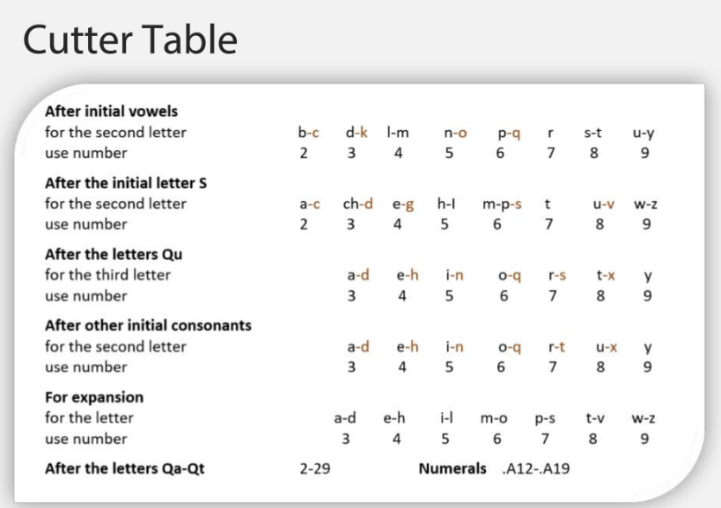

Sometimes, in the case of authors especially, the cutter number refers to a name. According to the Classification Schedule, in some instances the letter of the first cutter number is the second letter of the author’s last name. The numbers following it are generated by the table above. For example, the “S5” in the Cutter number above is a Cutter number that refers to “s-i” from the last name “Asimov.”
Occasionally, you will need to make a Cutter number for the book or author that is not from the Cutter Table. In fact, you should create Cutter numbers primarily based on availability of the Cutter. The number directed by the table may already be taken for one reason or another. The Cutter Table should be used only if the appropriate Table number has not been taken by another item or author in the catalog. The general rule is to avoid 0s, 1s, or 2s in your Cutter number. You should ensure that Cutter numbers are as short as possible and fit within the alphabetic listings already in the library. For example, if the Cutter Number for Strong is .S77 but there is already another author with Strong as a surname whose first name comes before the new author’s in the alphabet, the Cutter number might need to be .S78 or .S773 or .S774.
Author Cutter numbers are the second, and most common, cutter numbers. However, there are also topical cutter numbers. For instance, the cutter number for Acorns is A3. Bananas, on the other hand, are B3. If you cannot find a Cutter number, fit the number alphabetically between the other entries in the “A-Z” list according to the rules for author surnames in the paragraph above.
When creating Cutter numbers for works by corporate entities or societies, the same Cutter number should be used for all works. Years or work numbers (lowercase letters) should differentiate between parts of monographs and discrete resources.
When assigning a Cutter number based on a corporate or government-associated group, the broadest corporate name should be used to assign a Cutter number. For example, if the American Historical Association has a Cutter number of .A46, then the Utah chapter of that organization should also have a Cutter number of .A46. Jurisdiction areas for corporations, government-associated institutions, and government departments should be ignored unless they are in the title or the first subheading.
If departments of a government are responsible for a specific work, the name of the parent department should be used, not any of its subgroups. In a comparable fashion, only the first subheading of a government department or group that has multiple subheadings should be considered.
Editions and abridgments should have similar but distinct Cutter numbers. Translations of works should have the same Cutter number as the original work or edition, being distinguished by a year and/or another Cutter number.
When corporations are the subject of a work, that work should be assigned the same Cutter number as a work that was created by that corporation. This Cutter number should be accompanied by another Cutter number that specifies the author or the date. This will ensure that those who are paying attention to cataloging rules will know that the work is about a corporation rather than by a corporation.
The same thing is true if a person is the subject of a biography. If they are an expert on a particular subject and have created a work on that subject, a biography about them should be entered on that subject, with the same subject Cutter number. The person’s cutter number may be recorded but can also be replaced by that of the author of the biography.

Apply your Knowledge
Now let’s try to make some LCC Cutter numbers. Check out the LCC Outline, including PDFs that go into more detail than the list on the other LCC page. This will give you the first block of letters and numbers that should be included in the call number. Remember to be as specific as you reasonably can to give a unique cutter number to the item.
An interactive H5P element has been excluded from this version of the text. You can view it online here:
https://csi.pressbooks.pub/cataloging/?p=55#h5p-23
In order to create an LOC Cutter number, use the table above or go to https://calculate.alptown.com/. Use the website by clicking on “LC Cutter” (which should be the default selection anyhow) and typing in at least the first three letters of the last name of the author. In either case, be prepared to defend your answer using the table.
General Principles of Classification have been prepared by the Library of Congress to guide catalogers in assigning books to particular subjects in the LCC. For example, this document reviews whether or not to emphasize the geographic setting of the work over its subject. Catalogers are encouraged once again to be as specific as possible.
Expansion upon these principles is often necessary to be able to classify works and create call numbers for specific items. Catalogers often also need to be able to view entire classes as a group and organize them. To enable catalogers to handle the minutiae of their daily tasks, the Library of Congress created an Online Training on the LCC.
Sometimes it is best to learn about these things through reading, and obviously it is impossible to give guidance on every situation in a textbook such as this, even though it is online. The Library of Congress Classification and Shelflisting Manual will help you with any questions regarding best practices and tricky cataloging decisions.

Library of Congress. Cutter Table. Retrieved on December 6, 2022 from
.

IV

Classification Website Aids

10

Using OCLC Connexion
OCLC Connexion is a service that has proliferated across the world. Its purpose is to allow libraries to share MARC records and profit from each other’s work. There are multiple benefits to this tool, including standardization, learning from others’ perspectives and work, and saving time that would otherwise have been spent creating detailed MARC records.
Mostly, Connexion is used to perform searches for work catalog records that can be adopted by a local institution for metadata recording. Once you have signed into OCLC Connexion, go to the Cataloging page and ensure that you are searching through WorldCat’s records. WorldCat is the worldwide catalog created through the collaboration of all libraries that are part of the OCLC network.

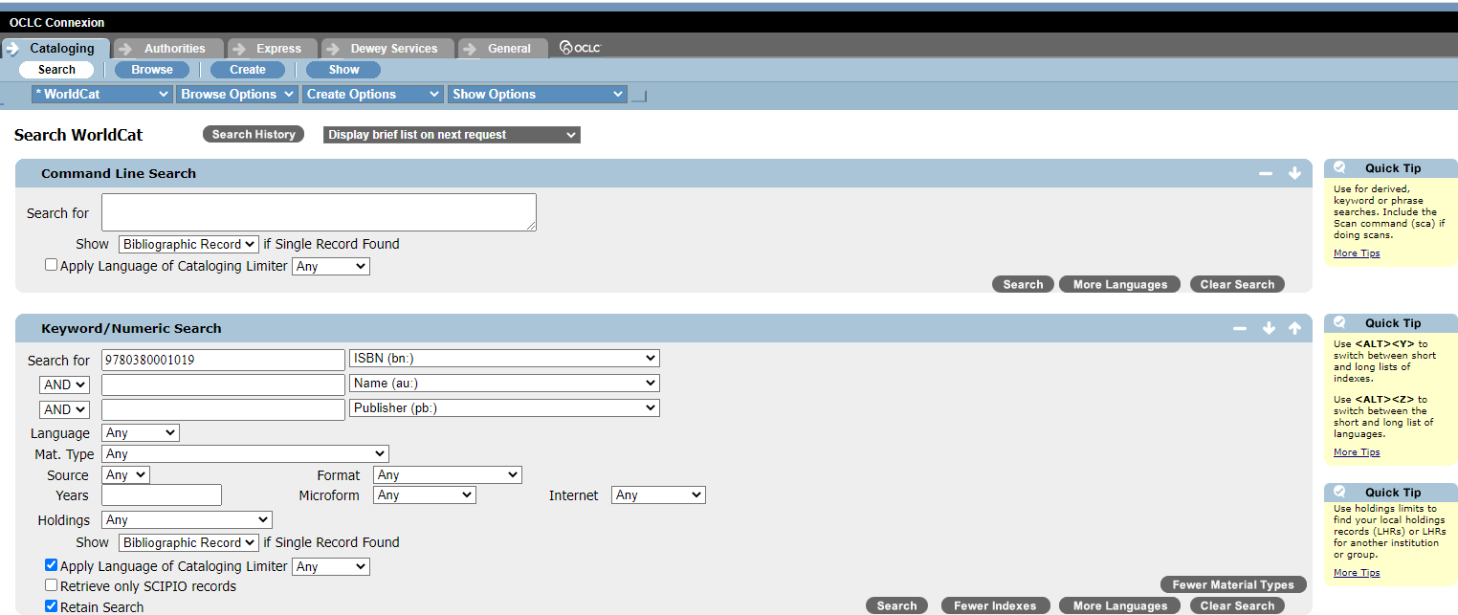

The most frequent search you will do in Connexion will be the “Keyword/Numeric Search.” You can search for a work’s title, the name of the author, the publisher, the language, the medium in which the work was presented, and the years of publication. Many other aspects of a work or item can be searched. Searches that are too broad or too specific may not result in any satisfactory results. For example, a broad search for “second foundation” in the title field, “asimov, isaac” in the author field and English as the language yielded over five hundred results.

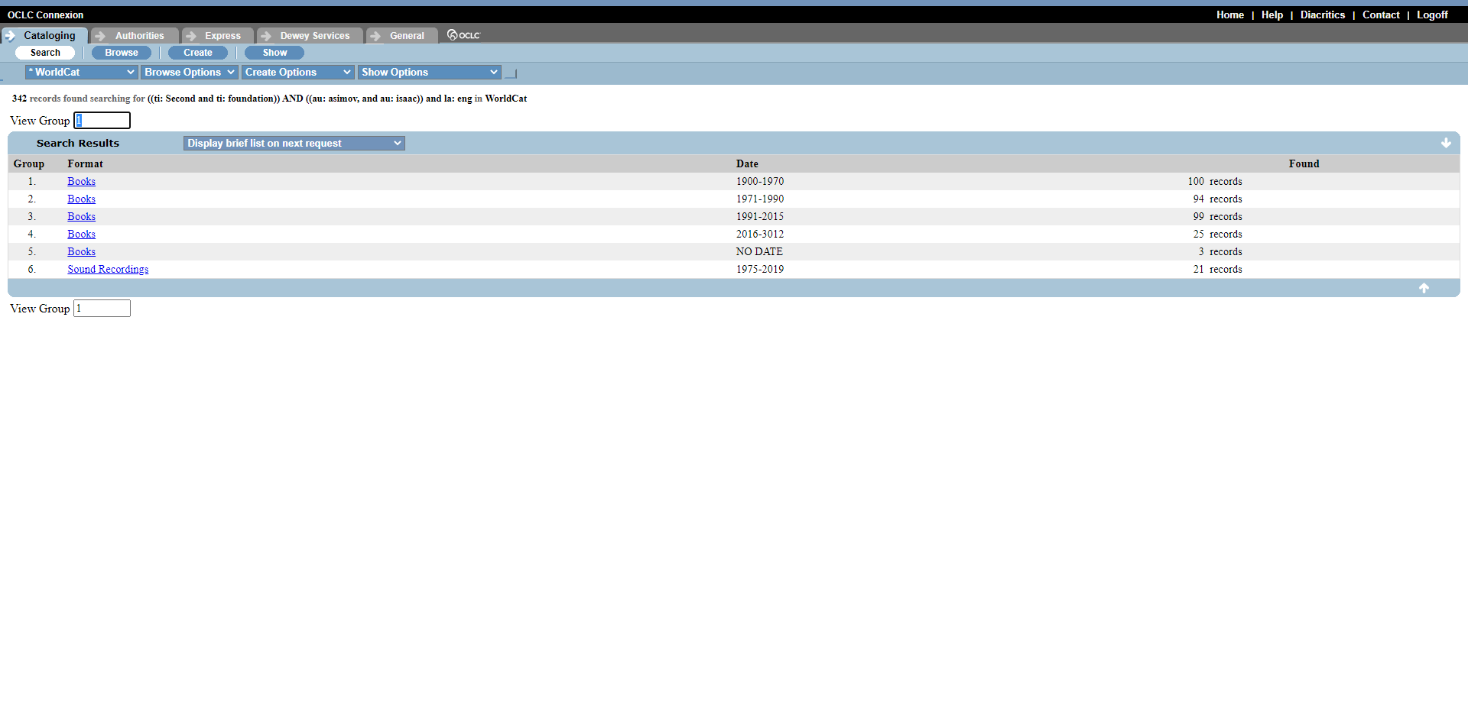

Once we included the year of publication, 1953, results were decreased to only thirty.

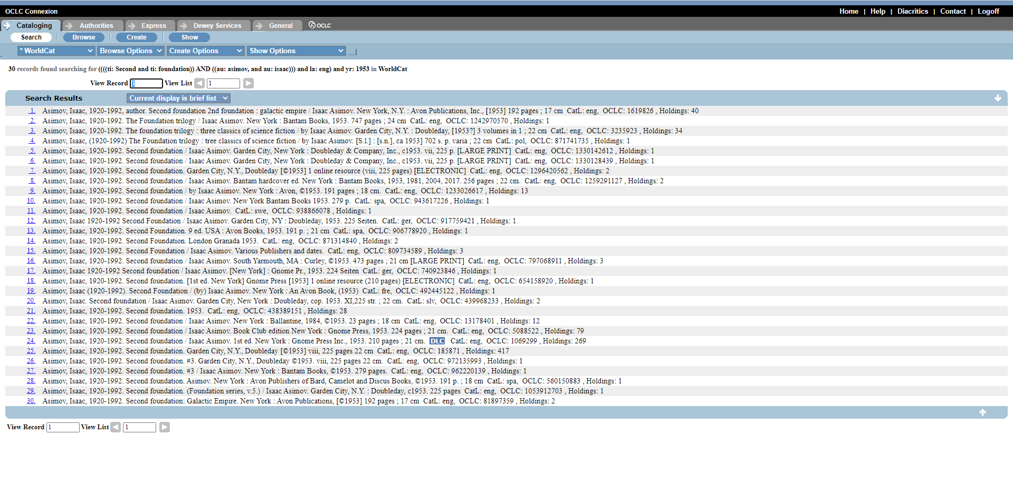

Including the publisher, Gnome Press, yielded three results. We were easily able to select the most accurate record from these three.

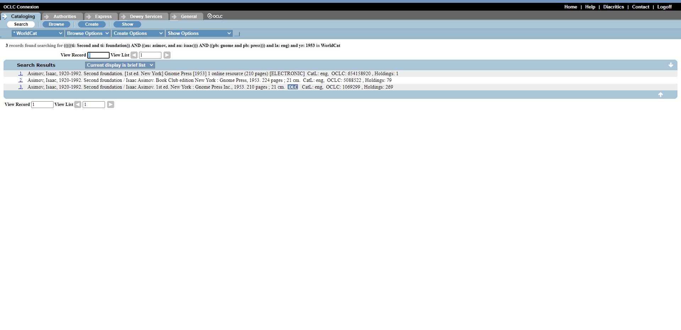

There are a myriad of searches one can perform on Connexion, including Title, Title Phrase, and Author. Title searches for keywords in the title, while Title Phrase looks for an exact phrase as typed in the search box. Remember that you should search for items with all lowercase letters, even if they are capitalized in the title or in a name. Titles in MARC records only have their first letter capitalized, and sometimes not even that. Also remember to search for people with their last name first, a comma, and then their given name.

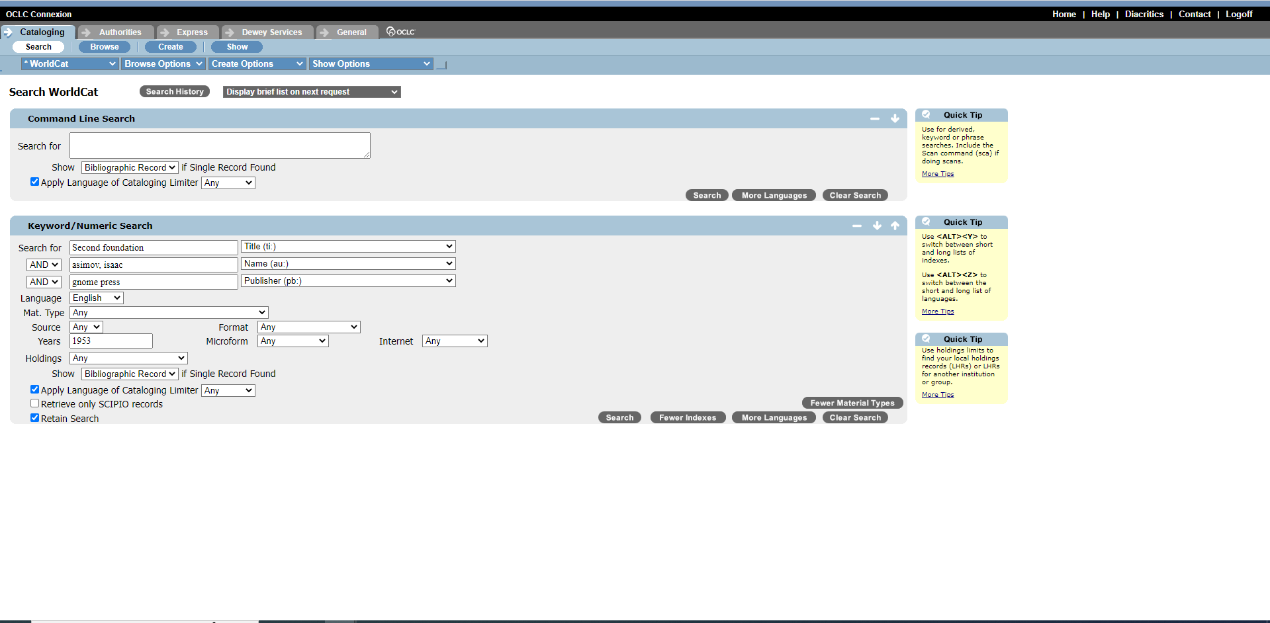

While it is less intuitive, you can search for items through the Command Line Search. Usually, this is beneficial if you know an ISBN to search for an item. However, you can also use a limiter in this search by using the symbol at the beginning of a Field designation in the Keyword/Numerical Search box. For example, if you are searching for a title word, type “ti:” and then the title keywords.
An interactive H5P element has been excluded from this version of the text. You can view it online here:
https://csi.pressbooks.pub/cataloging/?p=62#h5p-16
Usually, there are two informal ways to determine which record has the most accurate. The first is through the preponderance of use instances of the record. In other words, the record with the highest number after the label “Holdings” at the end of its summary in the results page is frequently the most accurate and thorough record. Another way is to examine whether or not the record has a blue label near its end. For example, a blue label of “DLC” is a sign that that record is the official catalog record used by the Library of Congress in its holdings. Results can be limited to DLC or other “blue box records” by selecting DLC in the Source section of the Keyword/Numeric Search.

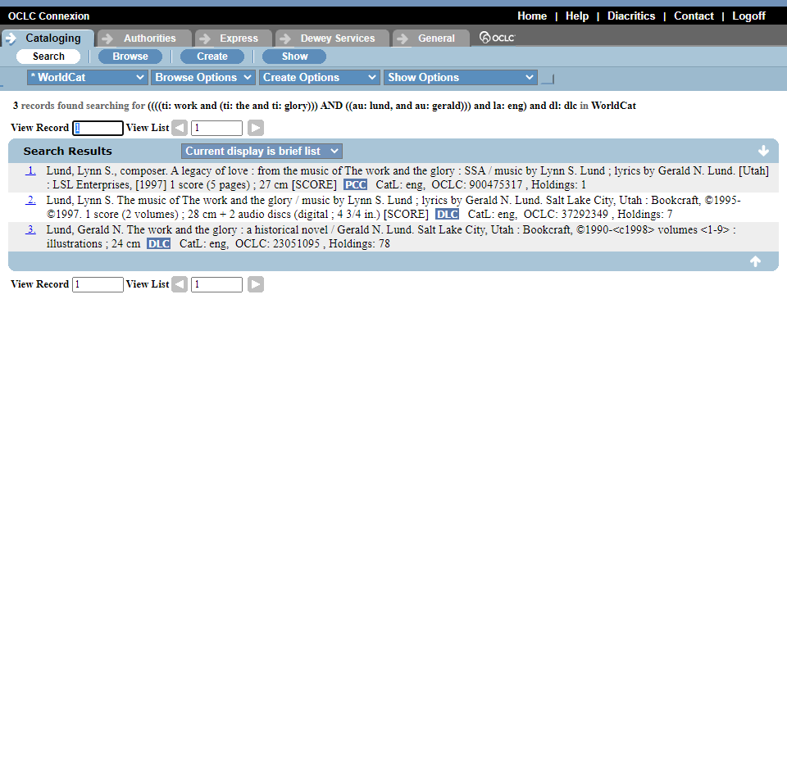

Click the number at the right of the catalog record in the results page that you want to use. You will be taken directly to a large MARC record for the work. You can see all pertinent fields and even print or export the record for your own uses.

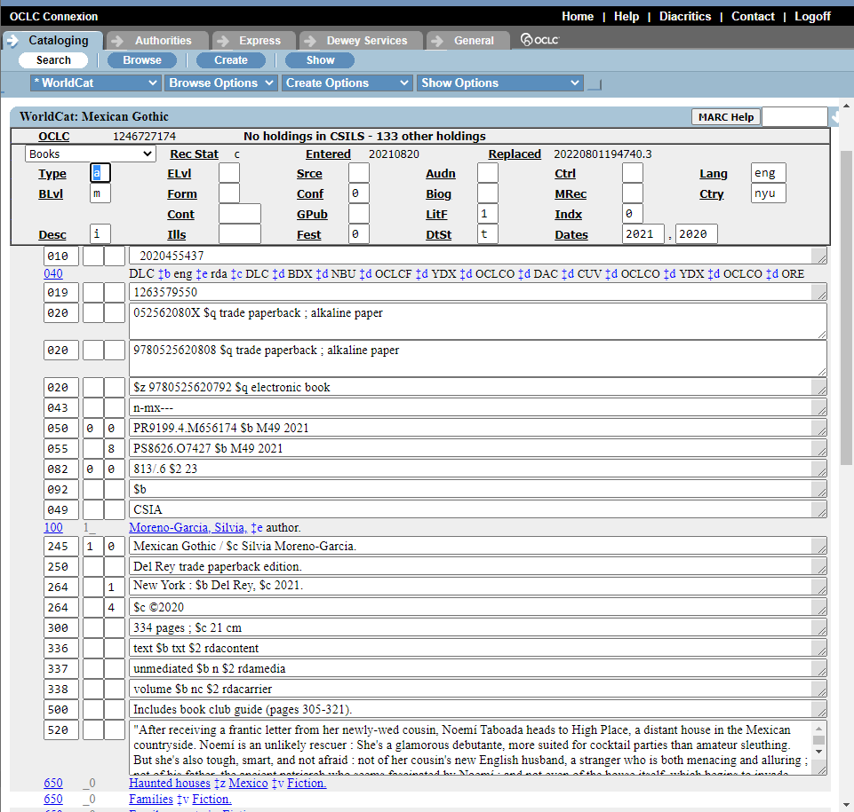

How do you access these files, though? One way is through Exporting. In the middle menu, click “Export Record in MARC.” Then, click on “Express” and “Download Export.” Click on the most recent record and you will have the record on your server. Other options for use include creating a local holdings record with your institution and viewing other local holdings on Connexion to request an Inter-Library Loan. These are other facets of library cataloging that will not be discussed in this course. They will be discussed, however, in the Introduction to Library Science course.
One can also search for Authority records on this system, but the Library of Congress official Subject and Name Authorities list is more… authoritative. Clicking on the Dewey Services link will take one to WebDewey.

11

Using WebDewey
Connexion and WebDewey are designed to be used together with ease, which makes sense because they were created by the same organization, OCLC. We will explore how to navigate WebDewey in a more detailed way than you have had to do for earlier exercises.

Home Page
Once you have signed in with your institutional login information, you will be taken to the standard home page of WebDewey.

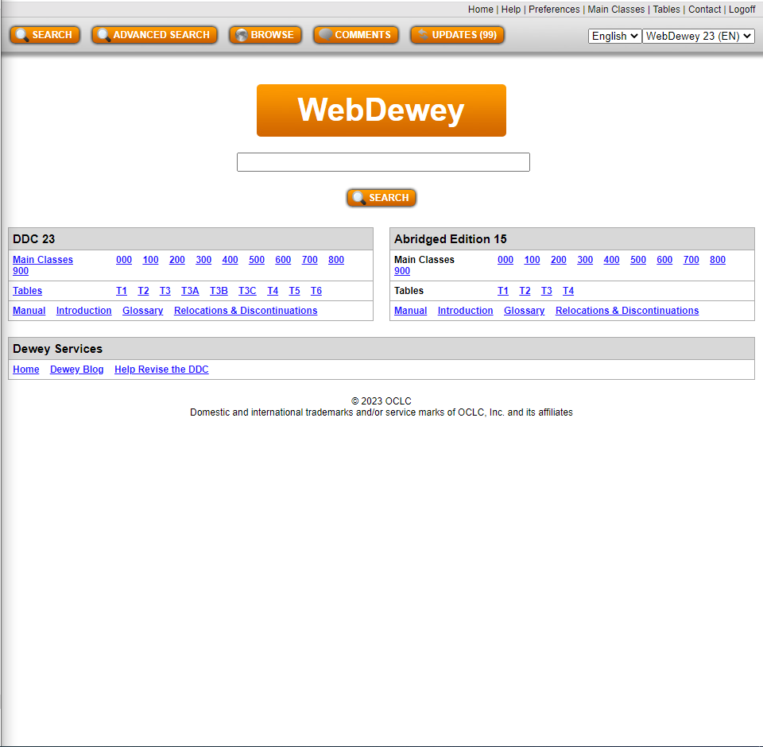

On the home page of WebDewey, there is a standard search bar with a button. This is useful for some searches, but there are also many other tools available on the home page that may be more immediately useful.
The top bar that has orange buttons has various ways of looking at the information contained with WebDewey. Aside from a regular Search option, there are also Advanced search and Browse options, as well as links to Comments and Updates. The Advanced Search and Browse options will be much more helpful than a regular search, as you will see through this description.
The bottom left of the home page has a table with three rows. These represent all of the information contained in the 23rd edition of the Dewey Decimal Classification System. The top row contains links to all main classes of the Dewey system, from 000 to 900 (or 0XX to 9XX). The second row contains the Nine Tables, from T1 to T6 (T3 has three subtables, named A, B, and C), that help catalogers append numbers based on subject, publisher motivation and publication type. The third row holds the Dewey Decimal Manual, and Introduction to the system, a Glossary of terms, and Relocations and Discontinuations information for past editions.
On the right side of the home page is an abridged edition of the Dewey Decimal System. This type of system is only on its 15th edition and has four tables instead of nine. The same resources for the unabridged edition are available for the abridged edition.

Navigating Forward
Now we will explore what happens when you decide to move forward in your investigation by clicking on one of the multiple options provided for finding a Dewey Decimal call number. Whatever you decide, you will eventually come to the same type of page that has standardized features and options.

Selecting a Main Class
If you proceed by selecting a main class from either one of the Dewey Decimal tables at the bottom of the home page, you will be taken to a page that has that class’ subclasses listed out. Some of these will be individualized and some will be in lists. For example, the range of 220 to 290 is listed as “Bible and specific religions.”

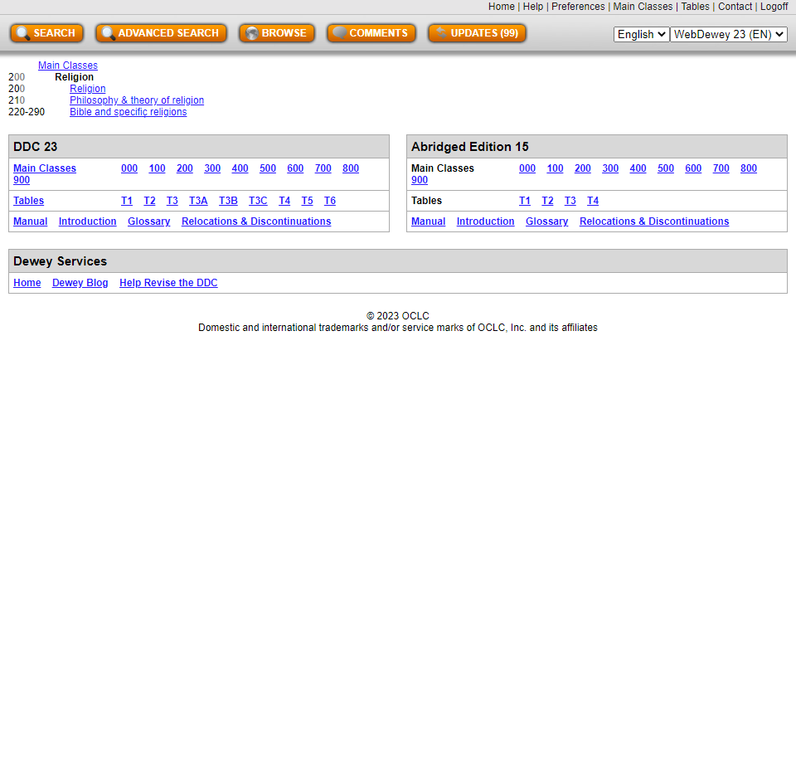

When you select one of these subclasses, or click on a range and get to a specific subclass, you will to taken to yet another subclass list, sometimes within the same page. Eventually, you will be taken to a page that lists the decimal points down to a degree of some specificity. As you progress further, your decimal numbers will have more places until you reach a point at which you cannot add any more subject levels. This is where you would go to a Table for additional numbers if needed.

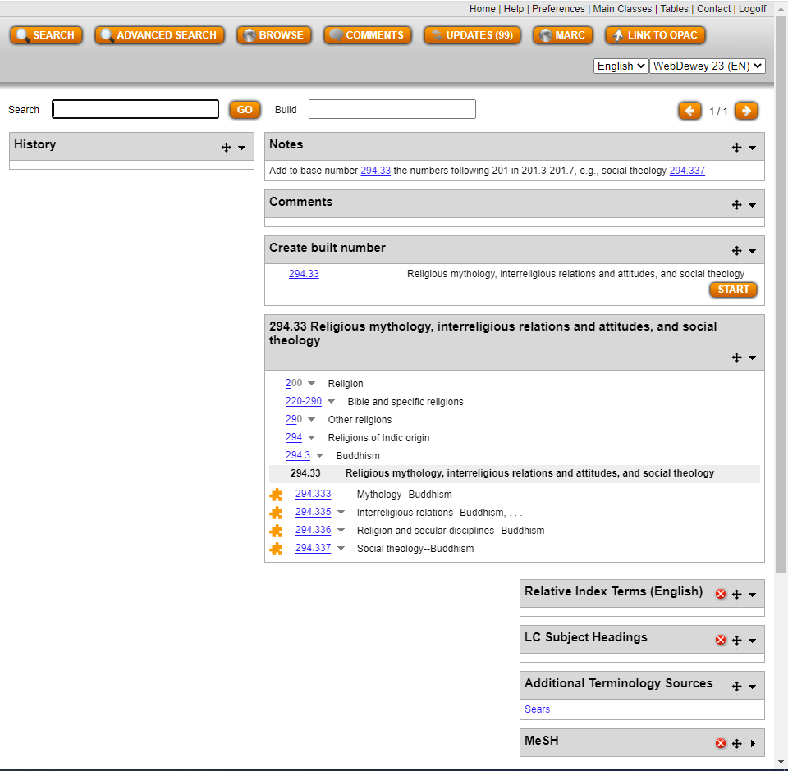

Selecting a Table
If you select a table, you will be taken to a page that has a large section of notes. These paragraphs will guide you as to how you should use that specific table. The most common Table used is Table 1. Links to specific numbers, the most common numbers, are given with definitions for those numbers. In a box with the Table Number followed by “Standard Subdivisions,” you can browse all numbers of the table beginning at the broadest categories and proceeding lower.

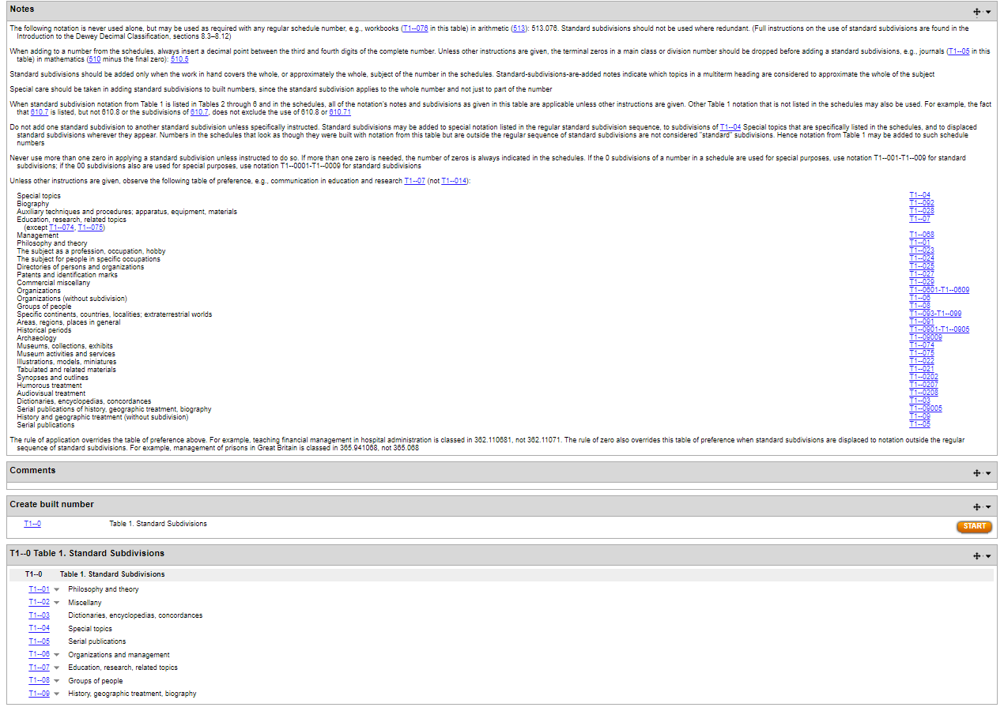

All table numbers begin with 0. Table numbers should never be used as as the basis for a Dewey Decimal number. Instead, they should be tagged on to the base number after the subject has been thoroughly identified. The “0” at the beginning of the number should always be included. If the base number ends with a “0”, the two zeros should be combined. For example, if the base number were 630 and the number from Table 1 was 03, the result would be “630.3,” which stands for “Agriculture–dictionaries encyclopedias, concordances.”

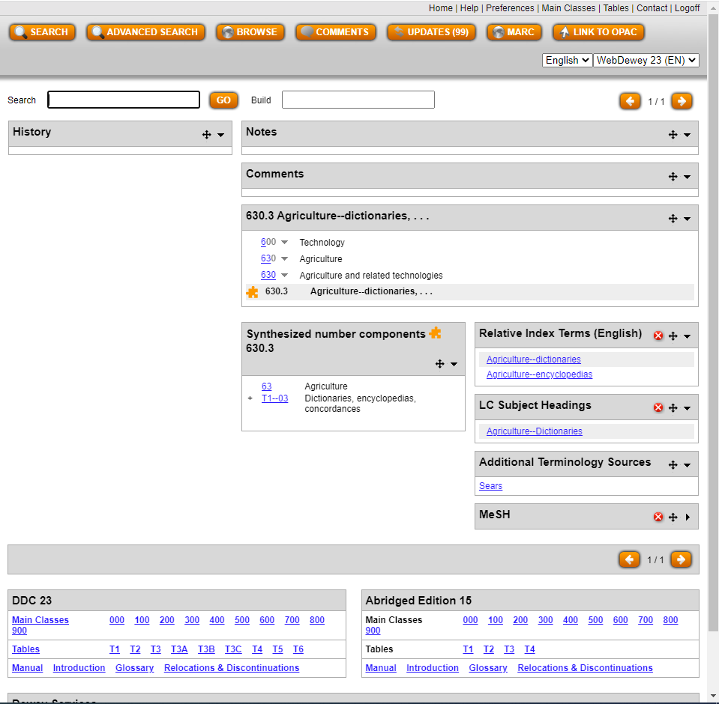

As you click on specific table numbers, you will be guided by notes that appear at the top of the page. As many of these notes say, you should not use the subdivisions unless they are specifically requested in the schedule or unless you have specific reason to. To prevent miscategorization, sometimes the notes state that certain types of works that may be categorized under this table number should be categorized in a specific subclass number instead. For example, the Table 1 number for biographies is 092, but the biography of an individual that is not related to a specific topic is reserved for subclass 920.

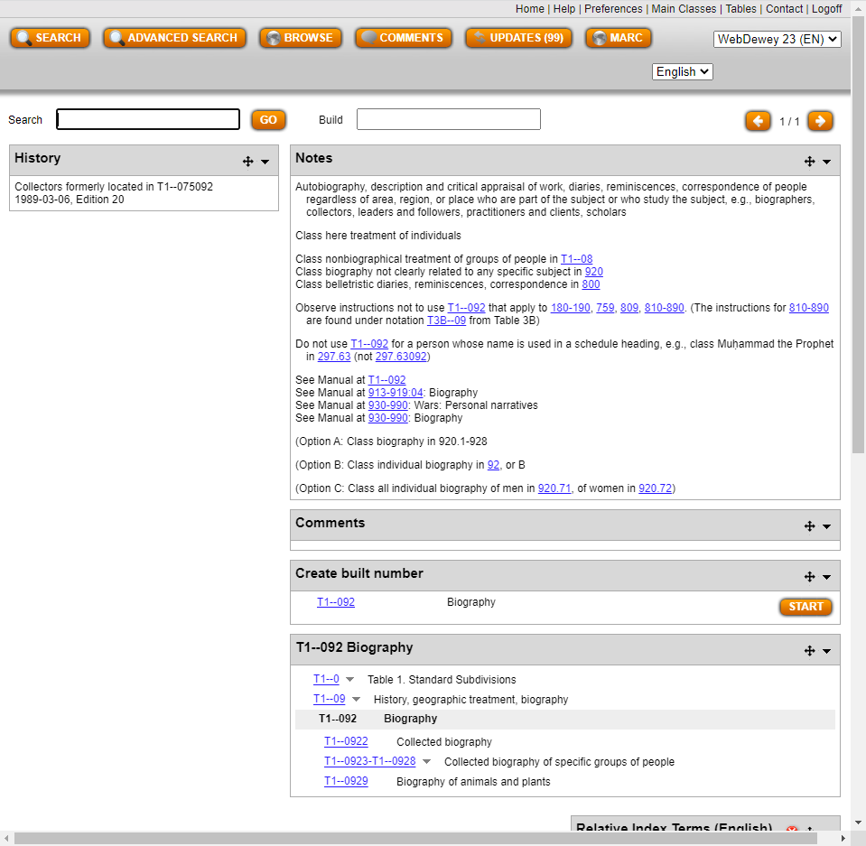

Proceeding with a Regular Search
The search button can be selected whether or not you have entered a query into the box. If one has used a search engine much, their first instinct will be to use this search option. However, it is only useful if one has patience and a keen eye. For example, if one searches for 351, the subclass of the Dewey Decimal System, which is likely what one was searching for, will be the 23rd results instead of the top result. Instead, the top 15 rows will be filled with Table numbers.

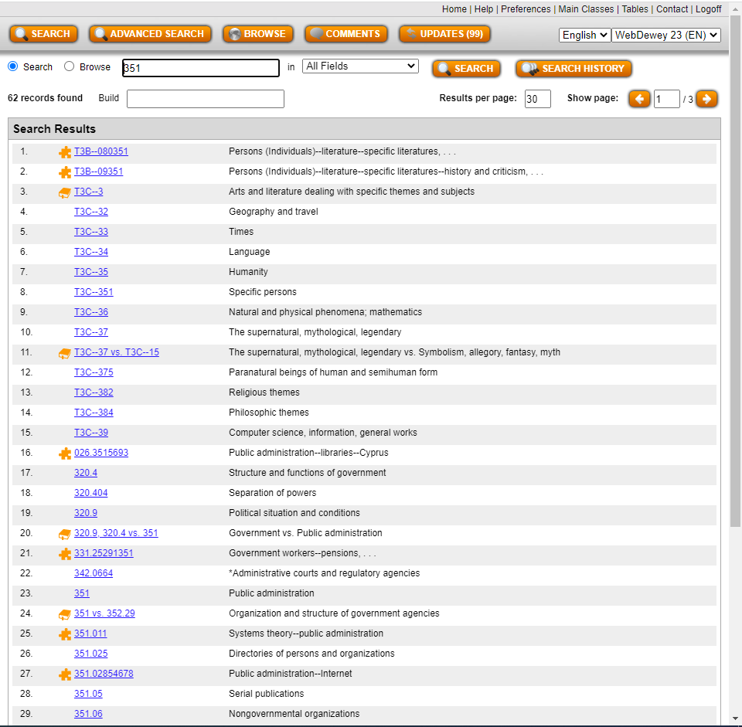

Clicking on the search bar with no query will lead to a results page that is empty. This will enable the searcher to browse through specific fields or search in specific fields. There are two bubbles next to the new search bar: Search and Browse. If one selects browse, the default field being searched will be the Dewey Numbers. Searching for 351 will result in the subfield by that label occurring in the second entry rather than the 23rd. Other options for browsing include the Relative Index list (a list of related categories), the Library of Congress Subject Heading list, and the MeSH and Sears systems, which we will not look into here.
Clicking on the Search bubble will allow searches through those options and more, including the Notes, Comments, and Author fields. Be aware, though, that Searching for Dewey Numbers rather than Browsing will still delay one’s search for the subclass. On the other hand, this may lead to exploring new possibilities. Searching for 351 in Dewey Numbers yielded a comparative result between subclass 351 and Dewey Decimal Number 352.29. This page contained notes on when each number was appropriate and less appropriate, as well as recommendations for similar numbers.

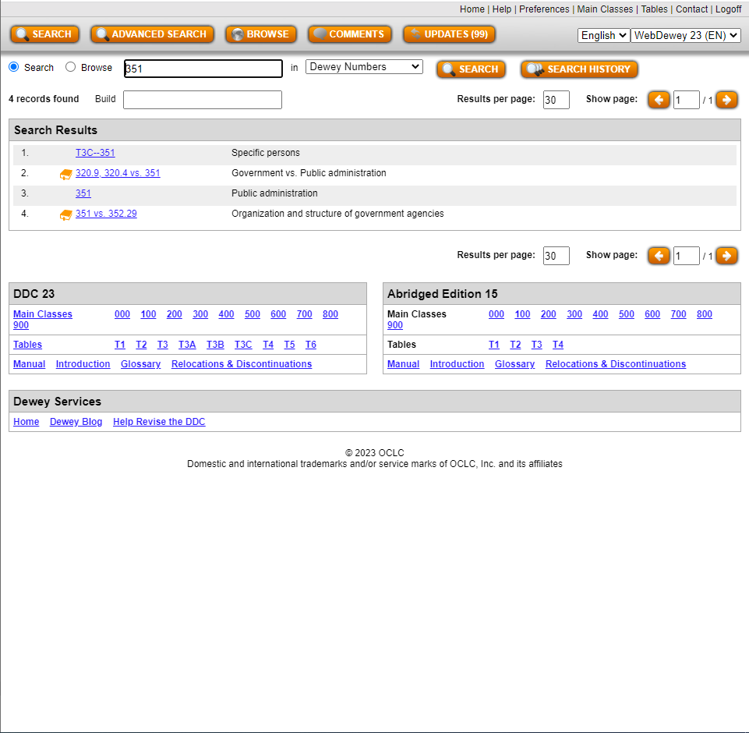

Proceeding with an Advanced Search
Selecting “Advanced Search” results in a page with five fields, three preset to search “Relative Index” and two preset to search the Library of Congress Subject Headings. All are connected with the “AND” Boolean symbols. The Boolean symbol can be AND, NOT, or OR. As many fields are needed can be used, and the others will be ignored. Often, only one or two fields will be used. This function can be used if one only wants to search the Relative Index or the Author fields. As far as the Library of Congress Subject Headings, it is already known that the most accurate database of these Authorities is the Authorities page maintained by the Library of Congress itself.

Browsing
Selecting “Browse” will lead to another iteration of the Browse option presented after an initial search. At this point the question may have arisen in your mind, “What is the difference between browsing and searching? Aren’t they essentially the same thing?” They are similar, but searching is more specific and intentional than browsing. When you browse, including using this function in WebDewey, you are looking for a general idea of the contents of a website or item. Searching includes looking for a specific results or piece of information.

Coming to an Acceptable Destination
Whatever method you select, you will eventually come to a page that has multiple boxes. Usually, the top will contain Notes on how to use the selection you have chosen. Below that will be a box for comments. The last large box will be the label of your selection, along with a logical record of how the selection fits within Dewey subclasses and the broad class. Below your selection will be possible options for more specific subjects. You can go as specific as the system will allow.
As you get into more specific numbers, sometimes a small box containing Table information will be provided. This will give information as to which tables were used to create a certain Dewey Decimal number.
Below the box labelled with your selection will be a box containing Relative Index Terms for similar subjects, followed by other sources for subject terms, including the Library of Congress Subject Headings Authorities page.
Above your selection will be a box labelled “Create built number” with your selection listed, along with an option to “Start.” If you need to research how a particular Dewey number was created, or if you would like to create a new number, this is how you should proceed.

Apply Your Knowledge: Creating Dewey Decimal Numbers with Tables
In these exercises, you will learn how to create Dewey Decimal Numbers through Tables. You will also demonstrate that knowledge at the same time. There is no way to learn faster than to practice!
An interactive H5P element has been excluded from this version of the text. You can view it online here:
https://csi.pressbooks.pub/cataloging/?p=60#h5p-13
As you learned through these processes, when building a number you should always make sure that you press “ADD” when creating a number when you have reached the most specific number in a list. Without that, the system will not recognize the addition as legitimate. This is a helpful feature so that categorization is not inappropriate. However, it can be difficult when you have to create a number and have no way of knowing where you went wrong. Creating Dewey Decimal subject class numbers requires both skill and concentration!

12

Using Classification Web
Classification Web is the site used by catalogers who are using the Library of Congress Classification System. There are multiple types of searches one can perform on this website, including through the schedules and tables and through subject headings. It has a somewhat complicated interface, but with some training it will be easy to navigate.
Before we continue let me recommend you to the Library of Congress’ Cataloging Workshop Page. This page is helpful even for librarians who have been in the field for years and years. The Online Training for the Library of Congress Classification

LCC Enhanced Browser
This is the second-most easy browser in Classification Web to use. It provides easy access to both schedules and tables of the Library of Congress Classification system.
At the top of the page is a standard search box with two menus. The first menu provides the option to search through either the schedules of the LCC system or the tables. Until you get down to more specific categories or forms, you will only want to use the schedules. The second menu provides searches through Class Number (the basic part of your call number) Caption (the subject associated with a call number), and Index terms or a combination of Index and Caption terms.
When searching with caption terms, it is important to know that caption searches are always “left-anchored.” This means that the query will be read from left to right and matched perfectly with any possible captions. Caption searches are useful, but are usually only productive if the cataloger already knows what the first word or first few words of a caption will be.
Searching the index can be helpful in some instances, but there are many problems with this feature of Classification Web. Only high-level terms are indexed, as well as some special topics. Geographical terms and corporate bodies are not indexed. Tables are also not indexed.
When searching for Index and Caption terms, it is imperative that you always double-check the schedule to ensure that the number you have found is appropriate and unrestricted. The schedules and tables can be tricky!
When I put “Raelian” in the Search bar and selected Schedules and Caption search parameters, first search result was the Raelian Movement, which is what I was looking for. The class number associated with this topic is BP605.R338. If I put “Raelian” and search automatically, the default search is a Class number, which takes me to completely different topics in the schedules. As with searching in OCLC and WebDewey, it is important that your parameters, or limiters, are correct before your search.
The text immediately below the search bar and above the schedule lists the hierarchy of your current selection in the schedules. The hierarchy for the Raelian Movement is “Islam, Bahai Faith, Theosophy, etc.–Other beliefs and movements–Works. By movement, A-Z–Raelian Movement.” Each of the levels in this line are hyperlinked to see how a particular topic fits within the larger groups.
When you click on the box next to an entry in the schedule, options appear to view that subject’s Dewey correlation, Bibliographic lookup results, results in the LC class browser, LC Subject correlation, relevant LCSH entries, and MARC display of that subject.
The enhanced browser is more accurate than the standard browser, which will be discussed in the next section. It also aligns with the Hierarchy Browser by providing actionable entries with hierarchy information at the top of the results page.

LCC Standard Browser
The standard browser is the typical browser that one would use on a typical search engine. It is not as helpful as an enhanced browser, but it is the most accurate representation of the LCC schedules. The main difference between this browser and the enhanced browser is that this browser does not include the tables. All table calculations must be performed manually by the cataloger. Links to the tables are provided, but they are not integrated into the browser. There is almost no reason that you should use the standard browser. You may use it if you already have an idea about the discipline into which a particular subject has been cataloged, but you might as well still use the enhanced browser to learn about the subject.

LCC Hierarchy Browser
The hierarchy browser is a further-enhanced browser that focuses on displaying one hierarchal level at a time. As you view one level, you can proceed one level down or go multiple levels up to see how lower hierarchical levels fit within higher ones.
Navigating this browser can be confusing, and it is a little tricky to understand because progression cannot be seen on every screen. In the Hierarchy Browser, you have to click on a particular category to see the lower levels. The result of the search is the highest category to which you can reverse your browsing, unless you search again with a different number.
While this browser may not appear to be useful, it can be particularly handy when you do not know which category an item should fall into. As long as you know the form of the item and a general subject, you should have relatively little trouble finding the base of your call number.

Results Options
Now that we have discussed the options you can use to find specific topics, it is time to discuss how to understand and integrate these results with your broader work. It is essentially useless to know an LC Number if you do not know how to make it communicate with other systems and functions of the library. Most of these are self-explanatory, but we will review each of them anyhow.

Dewey Correlation
The Dewey correlation option leads to a page that includes a Dewey number associated with that particular subject. For example, the Dewey number that matches most closely with BP605.R338 is 299. From that page, as well as from the original schedule display, you can go to a bibliographic lookup page.

Bibliographic Lookup
The bibliographic lookup option does exactly what it appears to do. This function looks for works according to a particular number. Be aware that if you look for books according to the Dewey Correlation Number instead of the original LCC number, the range of topics covered in the book will be much broader. For example, there were around three hundred works listed under the 299 Dewey number and only 2 listed under BP605.R338: mouvement raelien et son prophete: approche psychologique complexe du charisme and Aliens adored: Rael’s UFO religion.
Bibliographic Lookup eventually takes one to the Bibliographic Browse section of the Classification Web site. In this section, you can look for books by LC Call number, personal names, titles, subjects, Dewey call numbers, ISBNs, and record numbers as well as system control numbers. You can click on parts of the text record of a work, like the title and the author name. If you click on the title you can see books that have similar titles. If you click on the author name you can see other works by the same author. Clicking on the [Record] link shows a thorough MARC record for the work.
If you use Bibliographic Lookup to search for a book by LC Call Number, the books will be arranged by their record number. At the bottom of the result record are possible Library of Congress and Dewey Decimal call numbers.

Library of Congress Subject Correlation
If you click on this option, a Library of Congress Class Number-led results page will appear with subjects under its purview indented below each number. This will also be under the heading of Correlations. Below the number you have selected will be the next few entries in the schedule with their subjects.
The white box near each topic has a potential to lead to the Bibliographic Browse page, but unless the subject is a given name results of this action will be skewed.

Library of Congress Subject Heading
When you click on this option, you are taken to the “Subject Heading Browse” page. On this page, you can search by class number, subject heading, free-floating subdivisions (including pattern subject headings and subdivisions), unstructured headings and subdivisions, class number, and record number. Descriptions of these subjects, including whether or not a subject may be subdivided geographically, are also present on this page. Further indentations include information about other relevant subjects.

MARC Display of Subject
This page takes you to a page that has the specific MARC record related to a class number. You cannot progress past this page, but it is a wealth of information if you know how to interpret the data contained therein. You can take this record and put it into MARC records you are creating for items dealing with a particular subject. Information about the creation and modification of the record are also included on this page of the site. Records are downloaded in UTF-8 format.

Correlations Page
The correlations page is a massive search page that allows you to look for connections between Library of Congress Class numbers, Library of Congress Subject Headings, Dewey Class Numbers, Creator names, and NLM (National Library of Medicine) classification.

Other Options
The main menu that can be accessed by the three bars at the top left side of the page offers the opportunity to browse all of the topics above as well as demographic group terms, genre terms, children’s subject headings, and performance medium terms. Essentially, topics can be approached from a wide variety of angles.
If you click “New Search” on the top right corner, you can search all of these pages at the same time. Boolean functionality is fulfilled by placing words in multiple search boxes or putting multiple words with Boolean operators in one box. Options for a basic search include Class Numbers, Captions, Keywords, Index terms, and other terms. Filters for these searches, such as only showing tables or schedules, can be selected by clicking the “Search options” link.
At the bottom of the “Search options” section, an option to limit searches to particular schedules can be used by clicking the “Subsets” button.

Interpreting Results
Before you examine the results of your Classification Web browsing or search, you need to understand the hierarchy of the LCC system. In the schedules and tables, hierarchy is demonstrated by indentation, not the length of the number like in the Dewey Decimal System. The numbers are also not indicative of any particular subject or division. Again, this is a deviation from the Dewey Decimal System.
Periods are present in both the Library of Congress Call Number and the caption. Their presence in Call numbers has already been explained. In captions, there are multiple purposes. Periods can either show equivalent terminology for which other researchers have searched, arrangement instructions for subcategories, or synonyms or related topics that are categorized together despite being different iterations or aspects of the same subject.
Another important aspect of captions is the notes that may appear indented below them. One of the most common notes, which also appears in WebDewey, is the “Class here” phrase. This note explains the scope of the class. A similar but distinct type of note is the “Includes” note. This gives examples of types of works that can be included in a class but is not exclusive like the “Class here” note. “Subarrange” notes tell catalogers in which specific category certain types of works should be placed.
Other notes explore different topics through cross-referencing. “See” notes are for captions that do not have a Library of Congress Classification number assigned to them. These subjects are categorized under different numbers, and the “See” cross-reference note lists the caption and number. The “For … see” notes state that specific subdivisions of a subject should be classified under another number. “Cf.” notes are similar to “For … see” notes but are not as definitive. They merely suggest that a certain range of numbers may be more appropriate.
If a result has parentheses around its number, that number is not valid anymore. Most of the time, this is accompanied by a link to an updated number indented under the caption.
Bracketed numbers are numbers that local libraries can use in conjunction with the existing designations at the Library of Congress.

Selecting the Best Number
While the Dewey Decimal System encourages catalogers to create their own call numbers for works that do not exactly fit into a particular subject, the Library of Congress explicitly forbids most librarians from creating or proposing new call numbers. Instead, librarians should choose the best fit number. There are several rules you should always remember for situations in which you must perform original cataloging:
- Always catalog the subject of the item before you catalog it by its form, unless you are dealing with literature.
- Always keep in mind the author’s intent when writing the work.
- Always ensure that the first subject heading is incorporated into the call number, and try to include the second as well.
- Always make sure that the work’s author does not have their own individual call number.
- When dealing with multiple subjects, catalog an item based on its broadest subject and/or the first one mentioned if a call number does not exist for all subjects. If all items are covered equally and there is a call number for all subjects, choose a call number that covers a broader subject that immediately covers all topics discussed in the item.
- If there are multiple major topics, assign a call number that reflects the topic that fills most of the pages.
- At times a work will be about the influence of one subject on another. For example, the influence of the Chinese government on the development of Buddhism in China. In that case, you would classify the work in the context of the development of Buddhism in China. The influence of Chinese government would be given secondary, if any, importance. It would only be included in the last part of the item.

Apply Your Knowledge
Yes, now it is time for you to go and learn yourselves about the inextricable web of headings, class numbers, captions, and tables known as Classification Web. Good luck!
An interactive H5P element has been excluded from this version of the text. You can view it online here:
https://csi.pressbooks.pub/cataloging/?p=58#h5p-19
Parts of this page were adapted from the Library of Congress Classification Online Training created by Janis L. Young and Daniel N. Joudrey on behalf of the Library of Congress. As an official government publication, this training is in the public domain.

13

Library of Congress Authorities: Subject Headings and Names
Some metadata can be recorded in a variety of ways. For example, a summary does not have to include certain keywords in order for it to be valid. Additionally, a title does not have to have a certain number of characters to be considered authoritative. Other metadata, however, is standardized to avoid confusion. The general cataloging term for these specific fields of metadata is called controlled vocabulary, as you may remember.
The 600 fields that deal with people, works, places, and subjects have a special type of controlled vocabulary called an access point. These fields contain information that could be recorded hundreds of different ways. For example, the term for fiction related to scientific fields could be written “Science fiction,” “Science Fiction,” “science fiction,” “sci-fi”, “sci fi,” or any number of other possibilities. In order to ensure standardization, the Library of Congress has created one access point to go with each person, subject, or work. Not all works or people are represented, but most are. If a person or work is not represented in these access points, catalogers are encouraged to follow the general trend that is evidenced in the collection of access points as a whole.
The Library of Congress access points are referred to as Authority Records, or Authorities. This is my favorite part of cataloging. There is only one Authorized Authority Record for each entity. This prevents duplication.
There are multiple tools that someone can use to find Authority Records. The Library of Congress has provided a massive Name Authority File in database, also called LC Names. Users can search the database on the website.
Subject Headings also have a similar asset available. However, this resource is in a PDF form divided into multiple sections for each letter and number, in addition to an introduction.
If you are like me, you prefer a joint asset that combines both of these Authority Record groups. A massive Library of Congress Authorities Database was created, and users can search for Subjects, Names, Titles, combined Names and Titles, and All types of headings. In this case, Names means names of people as well as those of groups, corporations, and other organizations. We will use this site in all exercises on this page. You are encouraged to bookmark this site for your own use.

Navigating the Authorities Site
Searching through this database can be relatively tricky. There are many tips below the search box that can help you navigate this site.
One of the most important tips is to be sure that you are searching in the relevant category for your topic. If you search for subjects in the name category, for example, results can be skewed. Searching for “Asimov, Isaac” in the Subject Heading category leads to results linked to the Foundation series, which demonstrates the fact that Names of individuals can be used as Subject Headings as well. Searching for names of authors in the Subject Heading will result in a list of their works, which can be useful if you are searching for particular works as a subject of another work. You can also search for titles of works in the Titles section of the Authorities search.
When searching for names, always search in the “Surname, Given Name” format. Names in their normal order will not come up with correct results. This could even result in no results being returned.
Another major note is that you should ensure that your spelling is absolutely correct. While I was writing this page, I searched for “Asimov, Isacc.” This misspelling resulted in many Asimovs being returned. None of them were the correct Asimov. When I spelled the query correctly, multiple entries for Isaac Asimov for returned.
On that note, it is important that you select the correct Authority Heading for an individual. When you look at your results, there will be one that has a red button next to it. the third result in the “Asimov, Isaac” search, for instance, has an Authorized, Refs and Notes” button. Click on that button. An alternate version of this button says “Authorized Heading.”
When that red button is clicked, a large list containing the Authority Record, Scope Note, and alternative entries for the name and related subjects appear. Click on the Authority Record entry, which is usually the top item in the list. The Authority Record will appear at the beginning of that list again. Click on that, and a large MARC record for that Authority will be displayed. The Personal Name Heading, or the text after the MARC Field 100, is the name that should be used in Field 100 and/or 600. The Personal Name Heading for this record is “Asimov, Isaac, 1920-1992.” The Permalink, which may be included in a subfield of the 100 or 600 field, is lccn.loc.gov/n80126289. If you click on this link, more information will be provided, including the LCC Number most appropriate for that subject. This is especially useful if you do not have Classification Web (although you may not have the most accurate LCC Number if you rely completely on this method). The LC Classification of the Authority is also included, which in this case is PS3551.S5. This is the call number that would be used if an author were create a book about Isaac Asimov.
Biographical information of various types, including a list of works, may or may not accompany the Authority Record of an Author. In the case of a subject, a general description will accompany the record.
Another button will show a Labelled display that replaces the bold field headings with terms.
Another red button on the original search says “References.” An entry with this button will not be the Authorized Heading, but it will lead you eventually to an Authorized Heading for the individual represented by that entry. Whenever you click on a red button, make sure that you are clicking on a link for a heading associated with the Library of Congress Headings and not the Library of Congress Children’s Catalog headings (unless you are a children’s librarian).
Corporate names are also listed in the Name Authority database. This data will be displayed in a 110 field. Data in this field can be in the 410, 610, etc. fields of a work’s MARC record. Authority records and related information for names of individuals and corporate bodies can be used in similar ways to subject headings. Therefore, most operations that use or require subject headings can be adapted to individuals and corporate bodies.

Subject Headings
As stated above, the data in a 100 field for a person is the same as a subject heading entry about them. Subject heading data that should be used in a MARC record, on the other hand, is in the 150 field. Often, the Heading entry directly below the Permalink and above the MARC record is the same as the 100, 110, or 150 data. However, this is not always the case. Therefore, Heading entries should not be considered definitive.
When assigning subject headings and other authorities, remember these guidelines:
- Subject headings should be assigned with the broadest and most accurate subject first. If there are two subjects that are equally covered, they can both be included in the same heading. Call numbers will be determined using the first one and/or two subject headings.
- The term “subject heading” means multiple things.
  - Each “subject” recorded in an entire MARC field is referred to as a subject heading.
  - In a user’s perspective, a subject heading is also the first topic listed in a subject string, which has multiple topics combined with commas and hyphens (“Vocal music–France–18th century”).
  - All topics included after the first one in each of these strings are deviations from “Subject Headings” that are in the Authorities database. Since they are not the first topic in the string, they are called “subdivisions” or “subheadings.”

- After the subject matter, time and geographic elements can be included in the subject heading in that order. Geographic subheadings should only follow topic subject headings if those subject headings are designated MAY SUBD GEOG. If an entry says Not Subd Geog or has no decision, do not put a geographic subject heading after this category.
- See if subdivisions can be combined or if headings should be separated into two or more subheadings.
- Again, form subheadings should only be used as a last resort.
- The Authorities list, Classification Web, the Library of Congress Subject Headings Manual, and the Classification and Shelflisting Manual should always be referenced. Check authorities.loc.gov frequently.
- If a geographic area is assigned to a subject heading or is related to an event or movement that is the subject of a work, the corresponding Library of Congress MARC Geographic Code should be placed in the 043 field.
- If you feel that you should justify your inclusion of a particular subject heading or name, provide a 667 field with information from the Subject Heading Manual. If you would like to give users more information about a particular subject, include it in a 680 field.
In essence, subject headings are created of multiple Authority Record authorized data entries combined into a string of subjects according to the methods approved by the Subject Heading Manual. Always consult this set of documents before you combine subject headings and apply them to items in your catalog.

Classification Web and Headings
Although it is not as combined as the actual LOC Authorities page is, there is a way you can search for Subject Headings and Authorized Records of Names at Classification Web. Simply click the Subject Heading or Names button to be taken to a browser for those subjects. You cannot search for all keywords, but you can divide each of these two categories into smaller categories. For example, you can limit your search to only geographic or corporate names, only titles of works or series, or personal names, of course. Furthermore, you can search for Authorities by Class Number, the LOC record number, or by keywords.

Subject Headings in Specific Applications
Subject headings and names are virtually useless if they are not applied to a record for an item. This section is less about the regulations regarding their use and more about the format in which they are used. When writing public-facing documentation, the “Labelled Display” version should be used. When writing a MARC record, the appropriate MARC field entry should be used from the “MARC Display” version of the record page. For example, the 100 field of an Authorities page gives the approved heading with its appropriate subfields and indicators. For example, the name of a subject is in subfield “a” and the dates are under the subfield “d.” When entering this data into a MARC field, all that one has to do is to place the authorized data into an appropriate MARC field, replacing the “100” with “400”, “600,” “610,” or whatever field heading is needed. The subdivision symbol in the Authorities page can be replaced by $ or whatever subfield sign your institution chooses. When searching in ClassWeb or the Library of Congress, the subdivision symbols will be replaced by commas, parentheses, or dashes. Be sure to write the proper subdivision or subfield symbol before you enter subject and name data! For example, here are the subfield codes for Field 650:
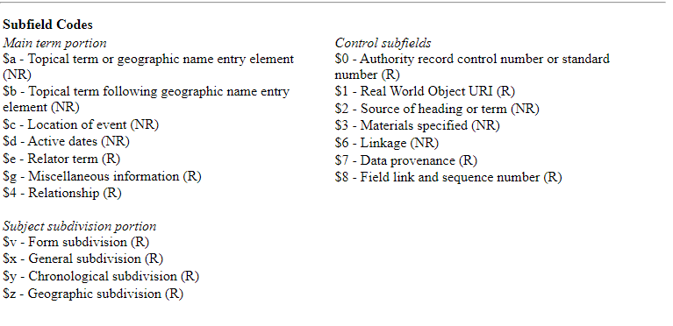

Apply Your Knowledge
Let’s go the Authorities page of the Library of Congress! See if you can find the most accurate subject headings for these items. Then, we will explore combining subject headings in accordance with the Subject Headings Manual. Good luck!
An interactive H5P element has been excluded from this version of the text. You can view it online here:
https://csi.pressbooks.pub/cataloging/?p=65#h5p-24
If you would like more information about the Library of Congress Subject Headings, please see the Online Trainingcreated by the Library. This training also examines the idea of controlled vocabulary, aboutness, and MARC formatting.

V

Shelving

14

Shelving, Shelflisting, and Work and Author Orders
After the assignation of the call number and the subject heading comes the wonderful task of shelving the book. This may seem to be intuitive, and it usually is for the Dewey Decimal Classification system. Therefore, we will not spend time examining that system. You simply place your book according to numerical order and the alphabetical order.
The Library of Congress, however, is another story. You might have already guessed this by the fact that the chapter on Classification Web is almost three times longer than OCLC Connexion and four hundred words longer than WebDewey. Just as coming up with a number in this system is more difficult, so shelving can be less intuitive. Fortunately, the Library of Congress has provided guidelines and regulations for assigning shelf places. An original work is placed first on a shelf, followed by:
- Subsequent editions
- Translations, also by editions of the original work
- Abridgements of the work, also by edition
- Criticisms or analyses of the original work
- Related works, whose editions, translations, abridgments, and criticisms also follow the same process.
- When a corporation or an individual is the subject of a work, those works should be given the same Cutter number as their own work products. They should be placed following the works created by the works’ subject. In other words, a biography of Boris Yeltsin would follow any work by Boris Yeltsin.

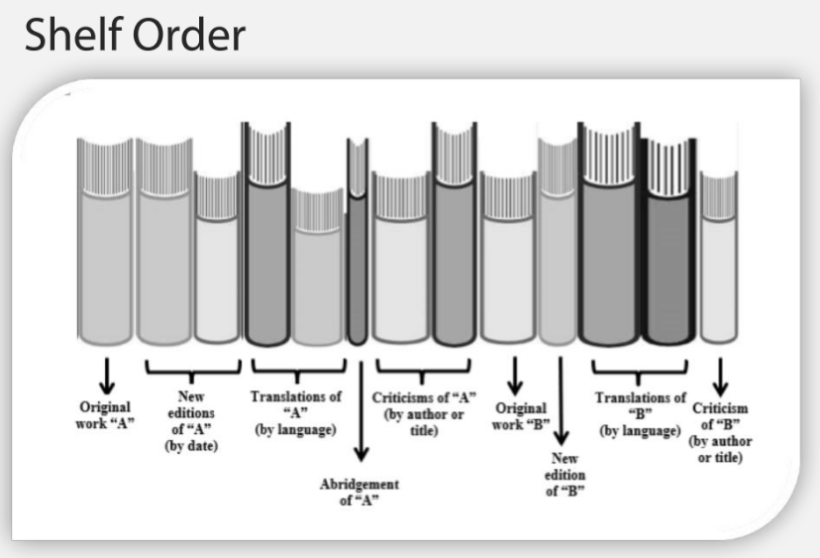

However, where do the original works go? There are a few rules for shelving that are the same as those for the Classification system:
- Nothing comes before something. In other words, works with only “V” should come before those that have “VB.” Additionally, 17 should come before 17.1, which should in turn come before 17.13.
- First Cutter numbers are the same as decimal numbers. Alphanumerical order is also followed (A comes before C, etc.).
- Cutter numbers are arranged discretely. Arrange works completely by the first Cutter number and then arrange works by the second Cutter number within the category of the first Cutter number. The second Cutter number is also called the first part of the item number.
- The last Cutter number, which is also called the second part of the item number, is the year. This should be arranged in the same way that the second Cutter number is arranged in categories of the first Cutter numbers. Chronological order should always be followed.
- At times, multiple works will be created by the same author in the same year. Some people will create unique first-or-second Cutter numbers. Others will follow another system which is more consistent. They will place lowercase letters for each work after the original one (2010, 2010a, 2010 b, etc.). These should be placed in alphabetical order.
- Remember again that nothing comes before something. In that spirit, items with one Cutter number should placed before those with two. Items with two should be placed before those with no year.
If a Cutter number includes both uppercase and lowercase letters, as some might do with the Dewey Decimal System, best practice is to file those discretely and alphabetically, word-by-word and letter-by-letter. Spaces and periods, hyphens, should be treated the same, and are used to signify yet another discrete unit in a call number. On the other hand, apostrophes should be completely ignored. If a word is an abbreviation of a larger word, such as Mt. or St., that spelling, and not the larger word, should be used.
When categorizing works by title, all initial articles in any language should be completely ignored. They should not be included in the catalog, or should be included after the rest of the title, preceded by a comma.
Compounded surnames, whether or not they have a hyphen, should be listed in author lists with the first part of the surname preceding the second. For that matter, surnames should precede first names, again being separated by a colon.
Diacritics and punctuation in titles and names should be completely ignored when creating shelf lists. If a name includes a character that is not typical, the Library of Congress Classification and Shelflisting Manual G100 section should be followed.
Another factor is the order of numbers and letters in initial order. Initial numerals should be shelflisted before, not after, letters. If numerals are after a name, which virtually only occurs in years of Authority Control Names, they should be listed in numerical order as well. If a number is part of a title, it should be listed before years.
Yet another factor is the ampersand symbol. When it appears at the beginning of a title, which is rare, it should be given precedence over numerals, which means it comes first in shelflisting order.
These rules can be helpful for Dewey Decimal Classification system shelflisting and ordering as well. For example, the suggestion to ignore diacritics and focus on the letter can help people who are making Cutter numbers in the DDC with authors whose first letter of their surname includes a diacritic.

Further Divisions
Dividing items by genre, language, and/or format may be necessary for ease of access. Whether an item is cataloged according to the LCC or DCC, these types of subdivisions may be necessary. This is why the section on these divisions is here rather than with sections on call number creation. Below are some rules for Dewey format and fiction division that have been adapted in some locations for other schema. For example, even though the College of Southern Idaho Library utilizes LCC, we still designate our Spanish materials with an “SPA” at the beginning of the call number for ease of access.

VI

Conclusion

15

Conclusion
There you go! Now you know the beginnings of all major cataloging schemata, theories, and systems. You also have had some experience with websites that are designed to help catalogers move swiftly through their work. To ensure that you know all of the major topics covered in this book, here are a few review exercises.
An interactive H5P element has been excluded from this version of the text. You can view it online here:
https://csi.pressbooks.pub/cataloging/?p=38#h5p-25
Congratulations! You demonstrated that you know how to use Connexion, WebDewey, and Classification Web separately and together. Furthermore, you demonstrated knowledge of FRBR, RDA, and MARC records. Once again I must acknowledge my gratitude for OCLC for allowing me to include visualizations of the processes for Connexion and WebDewey. Using all of these three systems together can make you a well-rounded and versatile librarian.

1

Appendix A: RDA to MARC 21 maps and workflows
For more information about RDA and MARC 21, including obtaining access to “maps,” go to https://www.rdaregistry.info/Maps/. Maps are documents that essentially act as crosswalks from one schema to another. We would include both maps for both bibliographic and authority MARC standards, but they are so immense that we cannot possibly include them here. Check the “MARC 21 formats” and “MARC Relator Codes” maps.
If you would like practice recording MARC data that is pertinent to RDA fields, use this table, which was adapted from that provided by the Library of Congress in their Cataloging Workshop page:
Field | Ind. | Data
Leader/7 |  | m
Leader/18 |  | i
008/22
008/35-37
020 |  | $a
040 | ## | $a DLC $b eng $c DLC $e rda
041
100
100 | 3#
110
111
130
240 | 10
245
250 |  | $a
264
300 | ##
336 | ## | $a text $2 rdacontent
337 | ## | $a unmediated $2 rdamedia
338 | ## | $a volume $2 rdacarrier
490
500 | ## | $a
502 | ##
504 | ## | $a
505
520 |  | $a
521 |  | $a
546 | ##
588 | ## | $a
7__
7__
7__
775
This table can be adjusted to fit your institution’s preferences for MARC records, fields, and subfields.
All documents on the RDA Registry website are licensed under a Creative Commons Attribution 4.0 International License. Documents featured in the Library of Congress Cataloging Workshop are in the public domain as they are government workproduct.

2

Appendix B: RDF and the Semantic Web
The existing cataloging schema are certainly detailed and thorough, but there are new developments in the world, specifically in the World Wide Web, that require a new type of cataloging. The Resource Description Framework is the solution to issues caused by the World Wide Web. In this framework, each item and individual is given a unique code. These codes are arranged in certain positions relative to each other and to special “relationship” codes. For example, an individual who is both an author and a subject of a book is given the same code in both instances. The only difference is the code’s position in the sequence of RDF codes. In one sequence it occupies the first position. In another sequence it is in the third place.
The Resource Description Framework is built upon the idea of Linked Data. This is a type of data that is used to connect items throughout the internet. One common way to explain linked data is to think of a document, say the Gettysburg Address. In the previous iterations of the Internet, the entire document was a basic unit of data. Through linked data, however, each concept and word of the Gettysburg Address is a discrete unit of data represented by a machine-readable code. The entire document is also represented by its own machine-readable code. Also, Abraham Lincoln is represented by a code. Thus, the document, its concepts, and Abraham Lincoln are all connected to each other. In this way, Abraham Lincoln can be connected directly with the subjects of the Gettysburg Address. Furthermore, he can be connected to others who also discussed the same subjects.
FRBR focuses on entities, relationships, and attributes. In a similar way, RDF and linked data focus on the relationships between entities. Another similarity to FRBR is that both items and authors are considered entities.
RDF uses a system called Terse RDF Triple Language, or Turtle, to organize entities and relationships. This system is also referred to as Semantic Triples or Semantic Triads. Thus, the digital structure created by all of these codes and their links is called the Semantic Web. Semantic triples have a particular order.
- Subject: These codes can be the same as Object codes. They stand for an entity. Subjects are the subjects of the record, or the item being describe. In a record about an item, the item being described is always the subject.
- Predicate: These codes provide specific enhancement for all code combinations in RDF records. In the case of triples, they provide information about the relationships between two entities.
- Object: These codes can be the same as Subject codes. They stand for an entity. Objects are the topic of subjects.
If I were to integrate RDF Semantic Triples into a record for The Foundation trilogy, I would write (3236412, http://purl.org/dc/elements/1.1/creator, http://id.loc.gov/auames/n8thorities/n0126289). This triple states that The Foundation trilogy, whose OCLC number is 3236412, was created by Isaac Asimov, whose URI is https://id.loc.gov/authorities/names/n80126289.html.
The predicate URI was obtained from https://www.dublincore.org/specifications/dublin-core/dcmi-terms/#http%3a%2f%2fpurl.org%2fdc%2felements%2f1.1%2fcreator. Dublin Core is an organization in Ohio that created yet another metadata schema specifically for use in archives and museums. They have a vested interest in Linked Data. Therefore, they host a number of initiatives and metadata specifications documents. The URI for the book was obtained from WorldCat. The URI for Isaac Asimov was taken from id.loc.gov, the Linked Data Service of the Library of Congress. URIs exist for subject headings, authors, formats, and other data points.
Linked data and RDF can be combined with RDA and other elements in MARC records to form a truly connected web. As MARC records, EAD (encoded archival description) records, MODS (metadata object description schema) records and other records in various schemata all describe digital and physical items, linked data can be used to include physical items in the digital network of information. Thus, a website in Vietnam can be linked through semantic triples to an artifact in a museum in Frankfurt. As we learn more about items and relationships, the connections will become denser and more complex. Linked data can promote swift communication between researchers and users all over the world.

3

Glossary
Cataloging

Content rules

controlled vocabulary

delimiters

Functional Requirements for Bibliographic Records (FRBR).

H5P (HTML 5 Package)

MAchine-Readable (Bibliographic) Catalog Records (MARC)

Resource Description and Access (RDA)

